Plant-Moose-Predator System Simulation Project.
Documentation.

The overall model is composed of the classes described in the list below in alphabetical order:
- AdvancedLandscapeSpecificationsFrame
- BasicLandscapeParametersPanel
- CustomPlantFrame
- Landscape
- LandscapeContainerPanel
- LandscapeModel
- LandscapeSegment
- Location
- Moose
- Plant
- PlantFrame
- PMPSim
- PMPSimAgentsFrame
- PMPSimMainFrame
- PMPSimMenuBar
- Predator
- QualityOfABite
- RandomNumberGenerator
- SimulationParametersMainFrame
- SpeciesDistributionSpecifications
- TimeLabel

Figures 1 and 2 illustrate the general relationships between these classes within the object-oriented Plant-Moose-Predator System Simulation’s internal architecture. Here, the class PMPSim at the top of Figure 1 is one of the variables of the SimulationParametersFrame in the top portion of the second diagram.

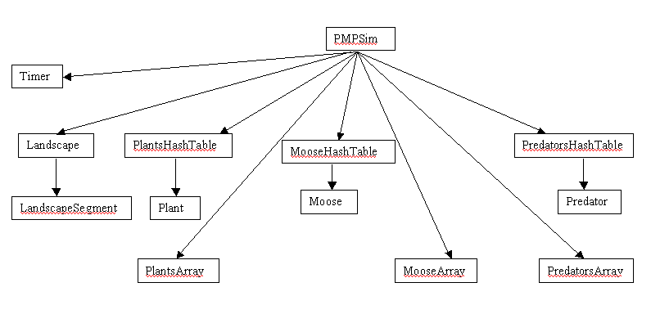 Figure 1. Internal Structure of the class PMPSim

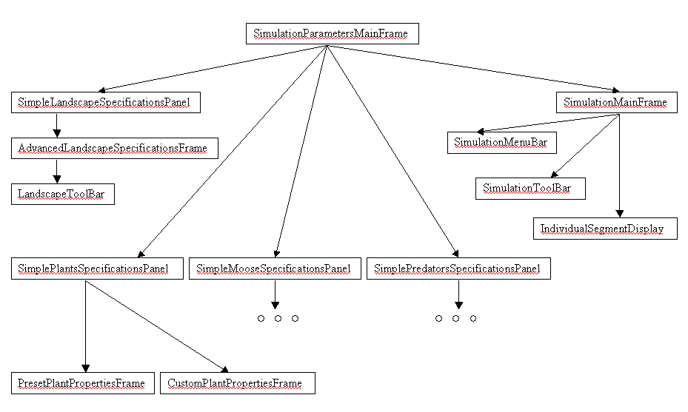
Figure 2. Simplified representation of the overall system architecture of the Plant-Moose-Predator System Simulation.

The following is the detailed description of all the classes implemented and the detailed description of the implementation.

PMPSim

This object is the heart of the simulation process.

Class variables:
Three hash tables containing all of plants, moose, and predators in the simulation, specifically, objects of type Plant, Moose, Predator are hashed according to their unique ids:
Hashtable plantsHashtable;
Hashtable mooseHashtable;
Hashtable predatorsHashtable;

Three arrays allow for sequential access to the agents currently in the simulation, they contain all the unique ids/hash codes of the agents stored in hash tables described above:
String[] plantsArray;
String[] mooseArray;
String[] predatorsArray;

This is the object for representing the landscape model of this system.
Landscape landscape;

Constructors:

Only a default constructor is provided, which purpose is only the initialization of the PMPSim’s main variables, leaving the rest of the setup process for the user.

Methods:

Creates a new landscape object given a value for the desired dimensions
initializeLandscape(Dimension)

Gets the landscape object, the return type is Landscape
getLandscape()

Methods for adding the agents to the hash tables of the simulation:
addPlant(Plant)
addMoose(Moose)
addPredator(Predator)

Methods for extracting the agent objects from the hash tables using their unique id values:
Plant getPlant(String)
Moose getMoose(String)
Predator getPredator(String)

AdvancedLandscapeSpecificationsFrame

Class variables:
A panel displayed in the upper portion of this frame, allowing for modification of landscape characteristics:
BasicLandscapeParametersPanel topPanel;

A panel displayed in the bottom portion of this form, allowing the user to cancel the specified simulation characteristics or accept them and move on to the next stage
JPanel buttonsPanel;

The button allowing for confirming all the specified values and assigning them to the landscape model.
JButton submitButton;

The button canceling all the changes made to the landscape model and returning to the SimulationParametersMainFrame.
JButton cancelButton;

The button that controls the visibility of the supplied toolbar allowing for the advanced specification process.
JButton toolBarButton;

The main panel of the this frame.
JPanel mainPanel;

The toolbar tool allowing for the advanced specification process and definition of elevation contours, bogs, wetlands, and similar parameters. This is defined as an inner class of this frame.
LandscapeToolBarFrame toolBar;

The main simulation object.
PMPSim simulation;

Constructors:

The supplied constructor takes requires only one parameter – the overall simulation object of type PMPSim.

Methods:

Enable the user to draw and view elevation contours:
elevationContourSetUp()
elevationContourViewAll()

Enable the user to draw and view wetland areas:
waterPatchSetUp()
waterPatchViewAll()

Enable the user to draw and view riparian habitats:
riparianPatchSetUp()
riparianPatchViewAll()

Enable the user to draw and view forest habitats:
forestPatchSetUp()
forestPatchViewAll()

Resets the view to default, where none of the specified properties are diplayed on the graphical model:
toDefaultView()

Methods for hiding and showing the toolbar frame:
hideToolBar()
showToolBar()

BasicLandscapeParametersPanel

Class variables:
Variables associated with the GUI components of this frame:
JPanel cellSizePanel;
JLabel heightLabel;
JLabel sqMeterLabel;
JPanel heightLabelPanel;
JPanel landscapeHeightPanel;
JSeparator jSeparator2;
JLabel xLabel2;
JPanel landscapeWidthHeightPanelPanel;
JLabel cellSizeLabel2;
JPanel heightWidthPanel;
JLabel landscapeHeightLabel;
JPanel widthLabelPanel;
JPanel landscaoeWidthPanel;
JPanel mainContainerPanel;
JPanel landscapeParametersPanel;
JLabel dimensLabel;
JLabel sqMeterLabel2;
JLabel equalSignLabel;
JLabel dimensionsLabel;
JLabel cellSizeLabel;
JPanel mainPanel;
JTextField inputWidthField;
JPanel heightWidthContainerPanel;
JLabel cellSizeLabel1;
JPanel dimensionsLabelPanel;
JSeparator jSeparator1;
JPanel landscapeDimensionsPanel;
JLabel widthLabel;
JLabel landscapeHeightValueLabel;
JLabel xLabel1;
JLabel landscapeWidthValueLabel;
JTextField inputHeightField;
JLabel landscapeWidthLabel;
JPanel secondMainContainerPanel;

Side length of a single landscape segment in meters, defined in LandscapeSegment as 10 pixels per meter:
int cellSize;

Value representing the width of the landscape in increments of the cell size:
int width;

Value representing the height of the landscape in increments of the cell size:
int height;

Constructors:

Requires three values for the class variables width, height, and cellSize, as specified above.

CustomPlantFrame

Class variables:

Declaration of all the necessary GUI components that have been created by default as a consequence of using the Sun One Studio tools:
private javax.swing.JTextField elevationRangeUpperBoundField;
private javax.swing.JPanel habitatAssociationsPanel;
private javax.swing.JTextField xAxisField;
private javax.swing.JLabel elevationRangeLabel;
private javax.swing.JLabel elevationRangeUpperBoundLabel;
private javax.swing.JLabel plantIDLabel;
private javax.swing.JCheckBox riparianAssociation;
private javax.swing.JLabel aspectPreferenceLabel;
private javax.swing.JRadioButton north;
private javax.swing.JRadioButton west;
private javax.swing.JLabel habitatAssociationsLabel;
private javax.swing.JTextField speciesNameField;
private javax.swing.JPanel speciesPanel;
private javax.swing.JPanel habitatRestrictionsBoxPanel;
private javax.swing.JPanel coordinatesPanel;
private javax.swing.JRadioButton east;
private javax.swing.JPanel elevationRangeLabelPanel;
private javax.swing.JPanel habitatRestrictionsPanel;
private javax.swing.JRadioButton none;
private javax.swing.JPanel habitatAssociationsLabelPanel;
private javax.swing.JButton cancelButton;
private javax.swing.JPanel specificCoordinatesFieldsPanel;
private javax.swing.JTextField elevationRangeLowerBoundField;
private javax.swing.JPanel elevationRangeFieldsPanel;
private javax.swing.JCheckBox wetlandAssociation;
private javax.swing.JPanel buttonPanel;
private javax.swing.ButtonGroup buttonGroup2;
private javax.swing.JCheckBox wetlandRestriction;
private javax.swing.JLabel xAxisLabel;
private javax.swing.JPanel elevationRangeContainerPanel;
private javax.swing.JTextField yAxisField;
private javax.swing.JPanel plantIDPanel;
private javax.swing.JPanel elevationRangeLabelsPanel;
private javax.swing.JPanel specificCoordinatesLabelsPanel;
private javax.swing.JLabel speciesLabel;
private javax.swing.JPanel aspectPreferencePanel;
private javax.swing.JRadioButton randomChoiceRadioButton;
private javax.swing.JRadioButton south;
private javax.swing.JPanel elevationRangePanel;
private javax.swing.JPanel speciesFieldPanel;
private javax.swing.JLabel coordinatesLabel;
private javax.swing.JPanel speciesLabelPanel;
private javax.swing.JPanel aspectPreferenceLabelPanel;
private javax.swing.JCheckBox forestRestriction;
private javax.swing.JPanel plantIDLabelPanel;
private javax.swing.JCheckBox riparianRestriction;
private javax.swing.JPanel habitatAssociationsBoxesPanel;
private javax.swing.JPanel mainPanel;
private javax.swing.JButton createButton;
private javax.swing.JLabel habitatRestrictionsLabel;
private javax.swing.JRadioButton specificChoiceRadioButton;
private javax.swing.JLabel yAxisLabel;
private javax.swing.ButtonGroup buttonGroup1;
private javax.swing.JPanel coordinatesChoicePanel;
private javax.swing.JPanel coordinatesLabelPanel;
private javax.swing.JPanel specificCoordinatesPanel;
private javax.swing.JPanel aspectPreferenceButtonsPanel;
private javax.swing.JCheckBox forestAssociation;
private javax.swing.JLabel elevationRangeLowerBoundLabel;
private javax.swing.JPanel habitatRestrictionsLabelPanel;
private javax.swing.JTextField plantIDField;
private javax.swing.JPanel plantIDFieldPanel;

Indicates whether this frame is generated for the purpose of creating a single or many agents, in which case specification of plant id and coordinates will be diabled:
boolean generatingGroup;

Constructors:

Creates a form of this type based upon the Boolean value of the input parameter specifying the generatingGroup variable.

Landscape

Class variables:

Modifications flag; set to true if the landscape is in the stage of being modified and false, otherwise:
private boolean modificationsEnabled = false;

Provides indication of the fact that the mouse is pressed within this panel:
private boolean mousePressed = false;

This value changes according to the color scheme specified below:
private Color currentColor;

The color scheme for defining landscape properties:
public static final Color defaultColor = new Color(204, 204, 204);
public static final Color elevationContourColor = new Color(204, 153, 0);
public static final Color waterPatchColor = new Color(0, 204, 153);
public static final Color specificPatchColor = new Color(102, 255, 153);
public static final Color riparianHabitatColor = new Color(51, 204, 0);
public static final Color forestHabitatColor = new Color(0, 102, 0);

Defines the parent panel, the panel within which the landscape is currently being displayed, this changes depending upon the current stage of the overall simulation, whether it is in the state of being modified or running:
private LandscapeContainerPanel parent;

Dimensions of the landscape, defines how many cells there are along the x and y directions:
private Dimension gridDimensions = new Dimension(1, 1);

Graphical components that together make up the overall landscape model:
private LandscapeSegment[][] segmentsArray;

Constructors:

The constructor provided only requires the user to specify the grid dimensions of the desired model.

Methods:

Set the parent panel in order to enable either the panel swap:
setParentPanel(LandscapeContainerPanel)

Returns the dimensions of the landscape grid
Dimension getGridDimensions()

Sets the dimensions of the landscape grid:
setGridDimensions(Dimension )

Sets the LandscapeSegment object at the specified location
setSegment(Location, LandscapeSegmen)

Returns the LandscapeSegment object at the specified location
getSegment(Location)

Returns a copy of segment at the specified location:
getCopyOfSegment(Location)

Enables/disables customization of the main landscape
enableModifications(boolean)

Checks if the modifications are enabled/disabled
areModificationsEnabled()

Handles single click mouse events when the landscape is in locked mode, in which case this action results in swaping of the segment selected to the magnified setup
mouseClicked(MouseEvent)

Depending upon the currently selected color, the distribution of appropriate characteristics within the landscape model occurs
setMouseToPressed(boolean)

Checks if the mouse is pressed:
isMousePressed()

Sets/gets the current color:
setCurrentColor(Color c)
getCurrentColor()

Distributing elevation contours within the landscape model:
distributeElevation(int)

Viewing elevation contours within the landscape model
viewElevationContours()

Distributing wetland areas within the landscape model
distributeWaterPatch()

Viewing the wetland areas specified for the landscape model so far
viewWaterPatches()

Distributing a riparian patch within the landscape model
distributeRiparianPatch()

Viewing riparian patches specified within the landscape model
viewRiparianPatches()

Distributing a forest patch within the landscape model
distributeForestPatch()

Viewing the forest patches within the landscape model
viewForestPatches()

Reset all the segments and hide all the associated properties
viewDefault()

LandscapeContainerPanel

Class variables:

Landscape panel that this is currently holding:
Landscape landscape;

The active segment is displayed in a separate frame allowing for magnified view of any segment in the current landscape model:
LandscapeSegment activeSegment;

The frame that is utilized to hold the above segment
JFrame activeSegmentFrame;

Constructors:

The specified default constructor requires the current version of the landscape of the overall simulation.

Methods:

Performs a swap between the panels. Takes in the location of a panel desired to be swapped, sets all the parameters of the current segment to the ones in the array, then gets a copy of the segment at the specified location and change the active segment to a copy of that one
performPanelSwap(Location )

LandscapeSegment

Class variables:

Coordinates of this segment in the Landscape grid
Location coordinatesInLandscapeGrid;

Reference to the main Landscape object
Landscape landscape = null;

Strings that contain the ids of the objects currently located within this segment:
Vector plants = new Vector();
Vector moose = new Vector();
Vector predators = new Vector();

Distribution patterns for all the user-specified types of plants, moose, predators
objects that are added to this vector are of type SpeciesDistributionSpecifications
Vector plantsDistributionPatterns;
Vector mooseDistributionPatterns;
Vector predatorsDistributionPatterns;

Dimensional specifications of a single segment panel – 10 pixels per meter:
public static final int defaultSideIncrementLength = 10;

This is used to change the side length of a single segment, the value of the variable described above is used to set the side length:
int sideLengthIncrement = 1;

Elevation parameter is in meters from the sea level, measured in meters:
int elevationValue = 0;
Other characteristics describing the relation of this cell to elevation contours, wetlands, etc.:
boolean isWaterPatch = false;
boolean isRiparianHabitat = false;
boolean isForestHabitat = false;

Constructors:

The default constructor provided requires the parent landscape and the set of agents that are to be distributed within this segment.

Methods:

Sets the default side length increment, this value is used to set the size of the segment, - here the defaultSideLength is multiplied by this value in order to create a segment of desired dimensions
setLengthIncrement(int)
getLengthIncrement()

Returns the dimensions of the single cell
Dimension getDimensions()

Methods to get/set location in the main grid:
Returns location of this segment in the grid
Locaiton getLocationInLandscapeGrid()

Returns the vector containting plants
Vector getPlants()

Returns the vector containing moose
Vector getMoose()

Returns the vector containing predators
Vector getPredators()

Sets the vector containting plants for this object
setPlants(Vector)

Sets the vector containing moose
setMoose(Vector)

Sets the vector containing predators
setPredators(Vector)

Returns a copy of the object of this class
LandscapeSegment copy()

Get the parent landscape of this segment
Landscape getLandscape()

Makes the object adopt the properties of the given one
makeLike(LandscapeSegment )

Methods to add new agents to this part of the landscape:
Add a new plant to this part of the landscape
addPlant(String)

Add a new moose to this part of the landscape
addMoose(String)

Add a new predator to this part of the landscape
addPredator(String)

Methods to remove new agents to this part of the landscape
removePlant(String)
removeMoose(String)
removePredator(String)

Definition of properties occurs only when the landscap is in the state of being customized:

Methods below handle the user-defined modifications and set the appropriate values for the overall setup of the
landscape of the simulation
mousePressed(MouseEvent)
mouseReleased(MouseEvent)
mouseEntered(MouseEvent)

Sets the value of elevation in meters specified for this segment
setElevation(int value)

Returns the value of elevation in meters specified for this segment
int getElevation()

Defines a bog/wetland area at this segment
makeWaterPatch()

Checks if this segment is a bog/wetland area
boolean isWaterPatch()

Defines a riparian habitat at this segment
makeRiparianPatch()

Checks if this segment is a riparian habitat
boolean isRiparianPatch()

Defines a forest habitat at this segment
makeForestPatch()

Checks if this segment is a forest habitat
boolean isForestPatch()

Overriding the default to draw the components
Outlines the Location of this segment in the overall landscape
paintComponent(Graphics)

Location

Joins together two integer values, which represent integer coordinates, as opposed to the existing java classes Point or Point2D

Class variables:
Int x – x coordinate
Int y – y coordinate

Constructors:

Provided default constructor requires two integer values representing the x and the y coordinates.

Methods:

Setting and getting the coordinate values:
GetXCoordinate()
GetYCoordinate()
SetXCoordinate()
SetYCoordinate()

Moose, Plant, Predator

The current implementation of these classes is very similar, so in this context they are described together.

Class variables:

The unique id:
String id;

Constructors:

There are two constructors specified: one requires no parameters, in which case the id is generated automatically, or the user has the possibility of specifying this String for manually by including this parameter in the constructor’s parameters.

Methods:

Gets the id of the agents:
String getId();

PMPSimMainFrame

This is the main frame of the simulation, which allows the user to interact with the system while it is in the stage of being run and monitored.

Class variables:

Reference to self:
PMPSimMainFrame mf;

Container for the Landcsape:
LandscapeContainerPanel landscapeContainer;

Associated menu bar component:
PMPSimMenuBar menubar;

Global simulation object:
PMPSim simulation;

Displaying the time step:
TimeLabel timeLabel = null;

Timer for the simulation:
Timer timer;

Constructors:

The simulation object is required in order to construct a new instance of this class.

Methods:

Creates a panel with a menu bar and toolbar in the upper portion of the frame
createTopPanel()

Creates a panel with a time counter
createTimeCounterPanel()

Creates a panel at the bottom of the screen, allowing the user to see the landscape layout
createBottomPanel()

This is a thread that updates the timer every second
UpdateTimer extends TimerTask}

Stops the timer of the simulation
stopTimer()

Updates the timer every second
startTimer()

Terminates the simulation
buttonStopActionPerformed()

Starts the timer for the simulation:
buttonStartActionPerformed()

Restarts the timer of the simulation
buttonRestartActionPerformed()

Close this frame
closeFrame();

PMPSimMenuBar

The purpose of this class is to provide the user of the Plant-Moose-Predator System Simulation with means for viewing the statics of the simulation being run
This toolbar resides on top of the main application frame called PMPSimMainFrame.java

Class variables:

Menu items for saving, loading, restarting, viewing agents’ statistics, and exiting the simulation:
JMenuItem save;
JMenuItem load;
JMenuItem restart;
JMenuItem exit;
JMenuItem viewAgents;

Constructors:

Default constructor is provided.

Methods:

Creates the tools and agents menus:
CreateToolsMenu();
CreateAgentMenu();

RandomNumberGenerator

This class is a tool for generating random numbers within this system.

Constructors:

Default constructor is provided, no parameters are required.

Methods:

Constructs a random integer between two given values, including the boundaries.
Int getIntBetween(int lowerBound, int upperBound)

Constructs a random double between two given values, including the boundaries.
double getDoubleBetween(double lowerBound, double upperBound)

SimulationParametersMainFrame

This is the first form the user is presented with once the simulation is started.

Class variables:

Associates GUI components:
private PMPSim simulation;
private JLabel sqMeterLabel;
private JPanel landscapeHeightPanel;
private JLabel xLabel2;
private JTextField numberOfPlantsField;
private JPanel landscapeWidthHeightPanelPanel;
private JPanel moosePanel;
private JPanel landscapeAdvancedSpecificaitonsPanel;
private JLabel landscapeHeightLabel;
private JLabel sqMeterLabel3;
private JPanel jPanel10;
private JButton submitButton;
private JLabel sqMeterLabel2;
private JPanel landscapeAdvancedContainerPanel;
private JLabel dimensionsLabel;
private JLabel landscapeCellSizeSpecificationLabel;
private JPanel containerPanel;
private JButton landscapeAdvancedSpecificationsButton;
private JButton cancelButton;
private JPanel jPanel7;
private JPanel landscapeCellSizeValuesPanel;
private JLabel xLabel1;
private JPanel landscapeAdvancedInnerSpecificationsPanel;
private JLabel landscapeWidthValueLabel;
private JLabel landscapeAdvancedSpecificationsLabel;
private JTextField inputHeightField;
private JSeparator jSeparator3;
private JLabel numberOfPlantsLabel;
private JLabel cellSizeLabel2;
private JPanel plantsPanel;
private JPanel landscapeWidthPanel;
private JPanel landscapeParametersPanel;
private JLabel equalSignLabel;
private JLabel landscapeCellSizeValueLabel;
private JPanel parametersPanel;
private JPanel mainPanel;
private JTextField inputWidthField;
private JPanel landscapeCellSizePanel;
private JPanel jPanel8;
private JLabel cellSizeLabel1;
private JPanel predatorsPanel;
private JSeparator jSeparator1;
private JPanel landscapeDimensionsPanel;
private JButton jButton4;
private JLabel landscapeHeightValueLabel;
private JLabel landscapeWidthLabel;
private JButton changeLandscapeCellSizeButton;
private JPanel jPanel9;
private JPanel numberOfPlantsPanel;
private JPanel bottomPanel;
private JPanel plantsSpecificationsPanel;
private JComboBox predefinedPlantSpeciesComboBox;
private JTextField numberOfCustomPlantsField;
private JButton addCustomPlantsButton;

Constructors:

A default constructor is provided with no required parameters.

Methods:

Create or redefine the landscape given the values of the appropriate text fields
setLandscapeParameters()

Resets the dimensions labels of this frame, this action is triggered by hitting the "Enter" key or the "Submit" button
resetDimensionsLabels()

Locks all the characteristics specified so far for the simulation object
and takes the user to the stage when the simulation can actually be run
activateTheMainApplicationFrame()

Activates the number of plants frame
activateCustomPlantsFrame()

Get/set the single cell size
int getCellSizeValue()

Set the value of the side length for a single cell in the landscape model
setCellSizeValue()

Start the applicaton GUI of the Plant-Moose-Predator System Simulation
void main(String[] args)

TimeLabel

Gives graphical representation for the simulation time step.

Class variables:

Relative units of simulation time step:
Int hours;
Int minures;
Int seconds;

Constructors:

A default constructor is provided with no required parameters;

Methods:

Increments the value of the displayed time:
Increment()

Resets the content of the label
ResetTimerContent()

Reset the content of the label to all 0s:
Reset();

The rest of the classes, not described above, have been implemented at the early stages of the development process and had been abandoned during the further implementation process. At this moment these classes are not employed by any of the other utilized code and have been kept only for the purposes of reference and for possible recycling of their components. Specifically, these classes are the following:
LandscapeModel
SpeciesDistributionSpecifications
QualityOfABite
PlantFrame
PMPSimAgentsFrame

In this case all the classes listed are java classes, so the “.java” extension is omitted

