Simple Photogrammetry Studio

Christopher T. Johnston
Table of Contents

1. Introduction 1
2. Project Overview 1
2.1 External Dependency 1
2.2 Data Objects 2
2.3 Data Files 2
3. Project Requirements 3
3.1 Functional Specifications 3
3.2 System Specifications 3
4. Project Overview 4
4.1 User Interface Design: Desktop 4
4.2 User Interface Design: ImageAssociator 4
4.3 User Interface Design: ImageContainer 5
4.4 User Interface Design: ImageList 5
4.5 User Interface Design: NewWorkspaceForm 5
4.6 User Interface Design: ShiftForm 6
4.7 User Interface Design: ShiftVoxelView 6
4.8 User Interface Design: VoxelView 7
4.9 User Interface Design: VRMCAlg 7
4.10 Object Relationships 7
4.11 Flow of Data and User Abilities 8
4.12 Volumetric Reverse Multiple Correspondence Algorithm 8
5. Software Development Process 10
5.1 Testing and Debugging 10
5.2 Work Breakdown 11
6. Results 12
6.1 Future Steps 12
7. Summary and Conclusions 12
Appendix A: User Manual 13
Appendix B: Code Listing 21

1. Introduction

Current methods for creating 3D models involve extensive amounts of user input. Programs such as 3D Studio Max®, MilkShape3D, etc. all involve vertex by vertex input or geometric primitive input from the user, then the user must manipulate the location and orientation of these vertices and their relationship to each other in order to form a final model. This process can take a mater of weeks or even months depending on the complexity of the model that is needed. A way around this point by point user manipulation is to take a set of rangefinder data that represents the object that will become the model. The problem with this is again time, money, and manpower. Your average weekend programmer doesn’t have the time or the money to gain access to the resources (i.e. equipment) needed to gather such data. SPStudio provides those programmers with a quick, effective, user-friendly method for gathering 3D about an object from a series of photographs. This data can then be used to create models that they can use in their programs.

2. Project Overview

SPStudio is not geared toward the general public, though the user interface is designed to be so simple that anyone with basic computer usage skills should be able to use it. The target clients are those people that are developing software projects that may include the use of custom 3D models. High School or College students who are attempting to create a game may find that creating the models to be used within the game is a project in itself. In general this software is designed to ease the development process for small and or under funded development teams that need 3D models in their projects.

Though the intent of this project is to provide a quick and user friendly tool to aid the model generation process for those developing software, it is possible for the general public to make use of the software as well. Should a development team release some software that utilized SPStudio to provide the models, it is reasonable to assume that some of the people who purchased the software will wish to add their own custom models. SPStudio will be designed in such a way that, should this be the case, anyone with basic computer usage experience can use it. By “basic” I mean that the user has an understanding of icons, menus, windows, etc. and how to use them.

2.1 External Dependency

CsGL is an OpenGL wrapper for C#. CsGL allows for OpenGL commands to be executed within a C# application. Renderable objects use CsGL to display themselves as OpenGL primitives. The OpenGLPanel uses CsGL to initialize the OpenGL environment and provide a location for the Renderables to be displayed.

2.2 Data Objects

Vector2D:
Consists of two doubles, x and y. There is a constructor provided that allows for a Vector2D to be generated from a System.Drawing.Point

Vector3D:
Consists of three doubles, x, y, and z. Also contains 4 boolean values indicating its inclusion within each of the 4 regions. Implements the Renderable interface allowing it to be drawn within an OpenGLPanel.

Line2D:
Composed of two Vector2Ds and is able to convert itself to a Line3D.

Line3D:
Composed of two Vector3Ds and is able to test if it intersects a given Triangle3D.

Triangle3D:
Composed of three Vector3Ds. Implements the Renderable interface allowing it to be drawn within an OpenGLPanel.

Voxel:
Composed of eight Vector3Ds. Implements the Renderable interface allowing it to be drawn within an OpenGLPanel.

2.3 Data Files

.wks:
This is the file extension associated with a saved workspace. The file is text based and when parsed provides initializing values for a Workspace and any ImageContainers that are associated with that workspace.

.sft:
This is the file extension associated with saved shift voxels. This file is text based and when parsed provides data for initializing Voxels. Shift voxels are voxels used during the shift phase of the algorithm. This file will not be created until after the algorithm has been run and the workspace is saved.

.mdl:
This is the file extension associated with saved finalized voxels. This file is text based and when parsed provides data for initializing Voxels. Finalized voxels are the voxels that have been found to reside in all four regions and are thus believed to represent the target object. This file will not be created until after the shift phase is completed and the workspace is saved.

3. Project Requirements

For this project there was no real client. In that sense I set forth to create requirements that I myself would like to have in the software. I also looked into possible features that other users may want by simply showing people my progress and asking for their input.

3.1 Functional Specifications

• SPStudio allows a user to save their progress at any time except while the algorithm is being run.
• SPStudio is fully graphical. By this it is meant that there should be no command line level user interaction. Everything should be handled with forms, buttons, etc.
• SPStudio provides the functionality to view (rotate and translate) 3D data sets that it has created.
• SPStudio provides the user with a progress bar to indicate algorithm completion.
• SPStudio allows the user to change image file associations at any time prior to the model building algorithm being run.
• SPStudio produces a 3D data set that is a reasonable representation of the real life object photographed.
• SPStudio allows multiple internal windows to be viewed in its personal desktop.
• SPStudio attempts to prevent the user from triggering events that cannot be performed at any given time.
• SPStudio allows the user to cancel the running of the algorithm.
• SPStudio’s error messages are written in plain English, and easily understandable. For example “Error: ArgumentException” is not acceptable, it should be replaced with “The file selected is not an image file. Please select an image file.”

3.2 System Specifications

The software was developed using C# in the Visual Studio .NET 2003 environment. Therefore it is designed to work in Windows 2000 or Windows XP and the .NET virtual machine must be installed. The minimum system requirements for which this software has been tested follows:

128MB of RAM
32MB Graphics Card with full OpenGL support
1.2 GHz Processor

4. Project Overview

C# allows for full Object Oriented support, but due to the need for data consistency between all objects the coupling is high and thus the design itself is not a good representation of Object Oriented programming techniques. The Object Oriented idea of having each object perform specific tasks that when combined with the work of other objects results in the desired output was a great aid in the development of the software. There is an order related to the data entry that was easily enforced through the use of objects.

4.1 User Interface Design: Desktop

The main form is the Desktop. All menu options are shown in its main menu bar, Desktop also acts as the “Multiple Document Interface” parent to all other forms. The menu items provided by the Desktop are:

File: Trigger Dropdown.
New Workspace: Create a new Workspace.
Open Workspace: Create a new Workspace using a .wks file.
Save Workspace: Save the current Workspace’s state as a .wks file.
Load Model: Load the .mdl file associated with the current Workspace.
Close Workspace: Close the current Workspace.

Image: Trigger Dropdown.
Add Image: Add a new ImageContainer to the current Workspace.

View: Make the ImageList visible to the user.

Run Algorithm: Run the VRMC Algorithm.

Shift: Activate the ShiftVoxelView and ShiftForm

4.2 User Interface Design: ImageAssociator

ImageAssociator is used to gather information from the user in order to create a new ImageContainer, or edit an existing one. It is implemented using ShowDialog which takes control away from the Desktop until the ImageAssociator is hidden or closed. This prevents the user from “messing around” until after the process is completed. The buttons and their functions are as follows:

Set Image: Prompt for an image file using an instance of OpenFileDialog, a form provided by the .NET system.

Set Degree: Verify that the String entered is in fact convertible to a double. Translate the value if it is less than 0.0 or greater than 360.0 accordingly so that it fits within 360.0 degrees.
DONE: Verify that an image file and a valid degree have been set. Hide the form and attempt to create the ImageContainer.

CANCEL: Hide the form and cancel the ImageContainer’s creation.

4.3 User Interface Design: ImageContainer

The primary function of ImageConainer is to display an image and allow the user to enter data through a point and click interface. The data is entered through the use of rubber band lines. An ImageContainer has two modes, Add, and Edit. When in Add mode a user can right click to add points on the image, a left click will connect the current line to the first point in the grouping, this is done to guarantee closed polygons. In Edit mode a user can drag already added points around the image. ImageContainer also provides functionality to remove itself from the workspace, as well as re-associate the image and degree that make it up. The menu options added to the Desktop are as follows:

Edit: Trigger Dropdown.
Remove: Remove this ImageContainer from the Workspace.
Re-Associate: Change the degree and/or image making up this ImageContainer.

Mode: Trigger Dropdown.
Add: Switch user input to Add mode.
Edit: Switch user input to Edit mode.

4.4 User Interface Design: ImageList

This form contains a simple ListBox that shows all images associated with the current workspace. By clicking on a name within the box the corresponding ImageContainer will become visible in the Desktop.

4.5 User Interface Design: NewWorkspaceForm

NewWorkspaceForm is used to gather information from the user in order to create a new Workspace. It is implemented using ShowDialog which takes control away from the Desktop until the NewWorkspaceForm is hidden or closed. This prevents the user from “messing around” until after the process is completed. The buttons and their functions are as follows:

DONE: Verify that a valid Field of View has been given. Hide the form and attempt to create the Workspace.

CANCEL: Hide the form and cancel the Workspace’s creation.

4.6 User Interface Design: ShiftForm

ShiftForm provides buttons for shifting the four individual data sets forward, backward, left, and right. This is done by pressing the button corresponding to the desired region and direction. Each press will move the specified regional data one voxel’s distance in the specified direction. The Finalize button will take voxels that are found to be within all four regions and remove all others, this is the finalized data set. Figure 1 shows the ShiftForm as the user would see it.

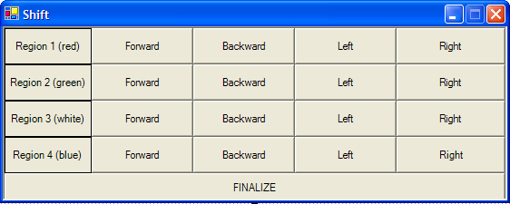

Figure 1. ShiftForm

4.7 User Interface Design: ShiftVoxelView

ShiftVoxelView contains and OpenGLPanel which allows the user to view the four regional data sets. The user can rotate and translate the view using the keyboard. In addition to the keyboard commands the ShiftVoxelView adds the following options to the Desktop menu:

Isolate: Triggers Dropdown
Region 1 (red): Shows the Region1 data set as red points.
Region 2 (green): Shows the Region 2 data set as green points.
Region 3 (white): Shows the Region 3 data set as white points.
Region 4 (blue): Shows the Region 4 data set as blue points.

Intersect: Triggers Dropdown
Region 1 (red): Shows the Region1 data set intersection with all other checked regions as red voxels.
Region 2 (green): Shows the Region2 data set intersection with all other checked regions as red voxels.
Region 3 (white): Shows the Region3 data set intersection with all other checked regions as red voxels.
Region 4 (blue): Shows the Region2 data set intersection with all other checked regions as red voxels.

4.8 User Interface Design: VoxelView

VoxelView contains and OpenGLPanel which allows the user to view the finalized data set. The user can rotate and translate the view using the keyboard.

4.9 User Interface Design: VRMCAlg

VRMCAlg provides a progress bar and status label so users can tell what the algorithm is doing. They also have the option to cancel the algorithm at any time. The buttons are as follows:

OK: Begins the algorithm.

Cancel: Stops the algorithm and cancels, or cancels before even starting it.

4.10 Object Relationships

Figure 2 below is a UML diagram that attempts to the relationships between the objects as simply as possible. A better understanding can be built from looking at the comments within the code for each class.

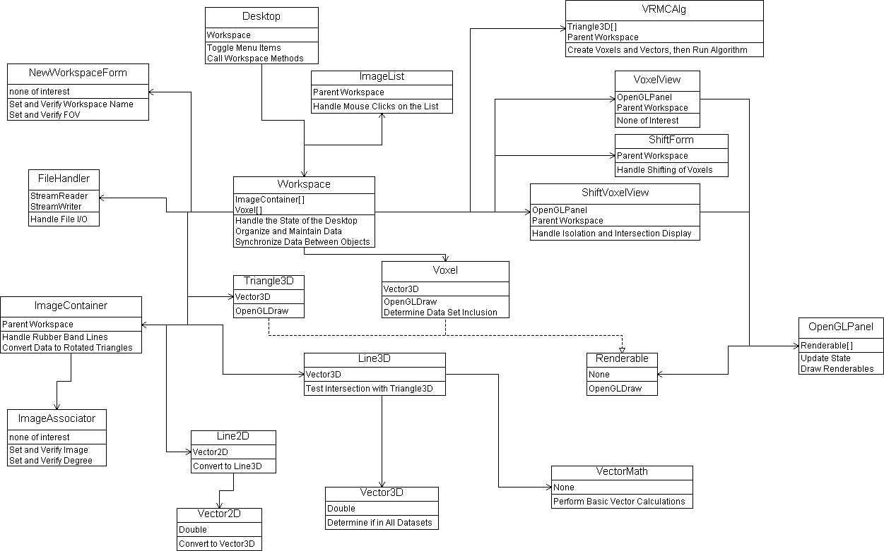

Figure 2. Object Relationships

4.11 Flow of Data and User Abilities

This application is designed to be user friendly; this includes preventing users from causing errors. This is accomplished through the enabling and disabling of menu items and forms based on the current state of the Workspace. For example if there is no Workspace then you cannot save it, so the button is disabled. The flow of data and what the user can do are linked. The flow is as follows:

First there must be an active Workspace. This can be done by creating a new one or opening a saved one.

Now the user is free to add ImageContainers to the Workspace, save the Workspace, close the Workspace, or attempt to load the saved finalized voxels associated with the workspace. If loading the saved finalized voxels fails then it simply means that the algorithm hasn’t been run yet, or that it was run but the workspace was not saved.

So long as there is one or more ImageContainers associated with the workspace the user can user the ImageList in order to access the ImageContainers.

If there is at least one ImageContainer corresponding to each of the four regions then allow the user to run the algorithm. If any of the ImageContainers are missing data then inform the user of the lack of data and don’t run the algorithm.

Once the algorithm is run the user now has access to the ShiftVoxelView and ShiftForm forms.

4.12 Volumetric Reverse Multiple Correspondence Algorithm

Algorithm Theory

This algorithm uses the idea that each line of a silhouette represents the intersection of a triangle whose points are as follows, one at the camera, and two at the endpoints of the line and the image plane. These endpoints are then projected to a plane parallel to the image plane that is the same distance from the image plane as the camera is from the image plane. This is done to compensate for depth distortion. These triangles are oriented with respect to the angle of the image that they represent. For each image the 3D triangles form what can be seen as a sort of cone shaped object.

The space occupied by the 3D triangles is then divided into tiny cubes (voxels). Each voxel is tested using a standard inside outside algorithm. Each point (8 in all) of a voxel is tested. If any of the 8 reside within the “cone” then it is determined that the voxel’s volume in virtual 3 space corresponds to the target objects volume in true 3 space. Typical stereo photogrammetric algorithms use stereo correspondence which is to take two points, one in one image and one in another. Then treat the two points in 2D as a single point in 3D. Using information regarding the two images, the algorithms are able to determine this new point’s location in 3D space. These methods require a user to specify a point in one image and then they must determine where this point resides in the remaining images. This requires an incredible amount of user input and also creates a considerable vulnerability to incorrect data entry. My algorithm works in reverse. My algorithm takes a point in 3D space and looks to see if it resides within the constraints set forward by the images, rather than taking points from the images and determining their location in 3D space. This reversed methodology allows for the simplistic silhouette data entry style that I have used in this software. The simplicity of the data entry method minimizes the probability that incorrect data will be sent to the algorithm, in addition to significantly reducing the amount of time required to enter data.

Even with the eased user input this algorithm is still subject to inaccurate data entry. This is often caused by the fact that it is nearly impossible to make sure that the images were taken exactly at the degree specified without highly specialized equipment. Also it is highly likely that the camera was moved slightly during the process of taking the series of photos. In order to compensate for these inaccuracies I added one more step in the process involving one additional, though simple, user input procedure. The algorithm produces four separate data sets. The first data set represent the algorithm’s interpretation of the object if it only analyzed the images from 0 to 90 degrees, the second data set represents the algorithm’s interpretation of the object if it only analyzed the images from 90 to 180 degrees, and so on. It is the intersection of these four data sets that will represent the finalized data set. The user shifts these four data sets around in 3D space in order to gain the desired intersection.

Each voxel corresponds to a portion of the volume of the target object. Unlike standard stereo correspondence methods, where two points in two images correspond to one point in 3D space, my algorithm works backwards. It takes a point in 3D space and finds its location in the images. This is why I chose to name my algorithm the Volumetric Reverse Multiple Correspondence algorithm.

Voxel Testing

The validity of a voxel is dictated by its visibility from all given degrees. This is found by using an inside outside algorithm. Each degree has a “cone” of triangles associated with it. By creating lines from each of the voxel’s corners to some point that is already known to be outside the “cone” we can count the number of times that the lines intersect triangles. If the number of intersections is a multiple of two then the point associated with that line is not inside the “cone”. If all of the voxel’s points are found to be outside then the entire voxel is thrown out. If even one of the voxel’s points is valid then we keep the whole voxel. By testing each of the voxel’s points we “jitter” the data, this reduces the probability that a voxel will be thrown out because it intersected an edge or point that is shared by two or more triangles. Though the problem of a voxel incorrectly being thrown out is addressed by the “jitter” there is the possibility that a voxel that should be thrown out will be found valid by the algorithm. This is addressed in the final portion of the algorithm where the user shifts the sub-objects. The few extraordinary voxels will be weeded out during this process.

5. Software Development Process

This software is in a state of evolution so I chose to use the prototyping method. The first prototype was constructed in my Advanced Graphics class and was very similar in look and feel to SPStudio. The difference is that in the original prototype there was no error checking. I did not intend for anyone other than me to use the product so I didn’t block commands and handle exceptions. The code was not commented and communication between objects was disorganized. SPStudio expands on the original prototype by creating a workspace environment that allows for much more information to be saved and retrieved. It also allows for more dynamic associations to be made between images. The name and location of images is irrelevant so long as they exist, in the prototype the name and location of images with respect to the workspace and degree that they were taken mattered. Exceptions are now handled and use input is tested for validity. In addition to increasing the usability prototype I also redesigned the use of pass by reference versus pass by value within the code. This reduced the runtime of the algorithm from hours to minutes.

5.1 Testing and Debugging

C# provides a very nice environment for creating Graphical User Interfaces. This is one of the reasons that I chose C# as the language for development. I didn’t need to test many of the components since they were deemed stable in the prototype. The main testing was in the use of references as opposed to values.

One of the largest problems I had was verifying that when an object’s member value was changed at one point in some code, that that change would be reflected in the instance. Thus the change would propagate through all objects that had handles on the manipulated object. This was difficult to test in that if it worked it worked and if it didn’t I would have to examine all objects that had handles to the manipulated object and analyze them each until the problem was found. In short what I am trying to say is that if something went wrong I had no idea where to look, I had to start at the top and go to the end. An example of this is follows:

Triangle3D was originally making references to the three Vector3Ds that represented it. The first Vector3D in a triangle represents the camera location. For a given group of triangles this location doesn’t change, so I only created one Vector3D to represent this point. The other two points of the triangle were created as needed. The problem arose when I tried to rotate the triangles. The two points not associated with the camera position would rotate properly, but every time I rotated a triangle it would rotate the point representing the camera’s position. Thus the triangles were being rotated incorrectly. This produced odd looking shift voxels, thus I knew something was wrong. What I didn’t know what where the problem was. Was the algorithm not working properly? Was I not traversing the Voxels properly? Was I not creating the Voxels properly? The list goes on.

I was able to resolve the problem by making Triangle3D renderable and viewing them. It was only after this that I was able to see that the problem was related to the triangles. Now a new set of questions arose. Am I rotating them wrong? Am I displaying them wrong? Am I generating them wrong? It turned out to be the third.

My testing methods were quite simple. I just ran the program over and over again trying to break it. This was difficult since I built so many safeguards into the user interface. The only bug that constantly plagued me was a refresh failure. If the algorithm was running and the user attempted to open some other application or clicked somewhere else on the screen the visual elements of the program would freeze. It would continue running and complete, after doing so return to normal, but to a user it looks like it broke. To avoid this I simply threaded the longest running method in the algorithm and it fixed everything. I verified my fix by running the algorithm then opening other applications before it had finished. The progress bar continued to move and everything was refreshing properly.

5.2 Work Breakdown

Figure 3 below is a Gant chart showing where time was spent during the development of SPStudio. I am happy to say that I was able to stick to the original schedule that I set forth. I believe the reason for this is that I already had a prototype built and due to my development experience with the prototype I was able to accurately estimate the time required to produce SPStudio. There were a few feature creaps near the end but took no more than a few minutes to implement.

Tasks | 01/18 |  |  |  |  |  |  | 03/10 |  |  |  |  | 04/24
Initial Planning
Compile List of Requirements
Initial Design
Write Proposal
Implement Primitive Components
Implement Complex Components
Link Primitive and Complex Components
Update Design Documentation / Testing
Verify That Requirements Are Met / Testing
Final Write-up / Presentation Preparation

6. Results

I would say that the SPStudio is a success. I was able to implement all of the functionality that I desired and most importantly I was able to decrease the runtime of the algorithm significantly.

6.1 Future Steps

Currently SPStudio generate data representing a 3D object. In the future this data will be analyzed in order to form a smooth polygonal model. It will also be expanded to texture map the model using the photographs. Beyond that is another upgrade that will provide functionality to use skeletal animation.

7. Summary and Conclusions

This project was developed in hopes that it will simplify the task of obtaining quality 3D data for use within other programs. The most difficult and time consuming portion of model building can be completed using SPStudio, through the use of the Volumetric Reverse Stereo Correspondence algorithm. SPStudio, with its powerful, yet simple graphical user interface, will hopefully allow other programmers to simplify the process of model generation.

Appendix A: User Manual

Minimum System Requirements

Windows 2000 or XP
.NET Virtual Machine
256 Mb of memory
1.4 Ghz CPU
32MB Accelerate Graphics Card with OpenGL support

Installation

Insert the CD and double-click on “install.exe”. Follow the On-Screen instructions.

Starting the Program

Run the program by selecting the SPStudio icon. Its location is dependant on your installation selections.

The program will start up and display and empty desktop. At this point you can Open a saved workspace or create a New one using the menu options in the File menu.

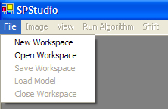
Taking the Photographs:

The algorithm uses a set of digital photographs. Each image is a photograph of the object that the user wishes to model. The constraints for the photographs are as follows:
• All photographs must be of the same resolution (i.e. 640X480, 1028X768, etc.).
• All photographs must be taken the same distance from the object.
• The camera’s Field of View must be known.
• The first photograph taken is said to be taken a 0 degrees. The object is then rotated clockwise X degrees. The new image is said to be taken from X degrees.
Figure 1 below shows a small example of the photographs. The images shown (starting from the left) represent 0 degrees, 10 degrees, 20 degrees, and 30 degrees. They are all 480X640 in resolution and were taken with a digital camera purchased at Fred Meyer on sale. The wooden circle at the bottom of each image is a simple rotating base that has 36 marks on it indicating 10 degree increments. I assembled this in about 20 minutes and the materials cost me less that $20. Remember that this software’s purpose is to provide a cheap and simple method for 3D data gathering. A much more accurate base could be built and a more expensive camera used, but to better express the mission of the software I chose to keep materials as cheap as possible.
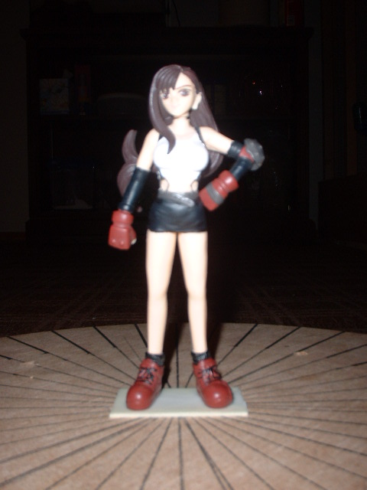
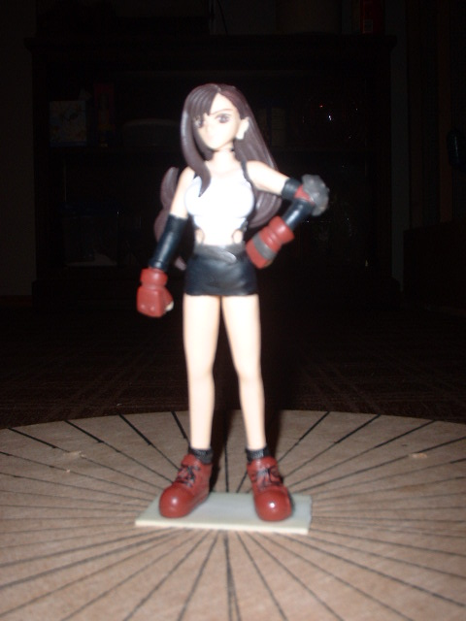
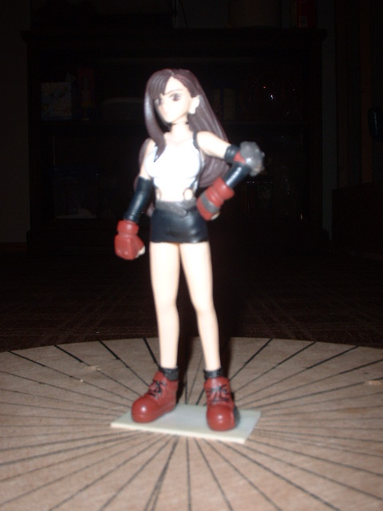
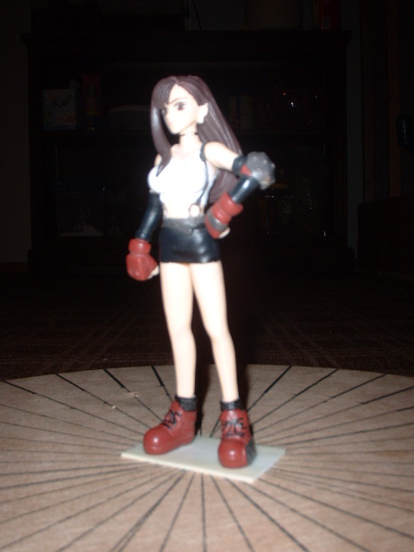

Opening a Saved Workspace:

Selecting “Open Workspace” will trigger the file selection window shown below. The file selected must be in the WKS format.

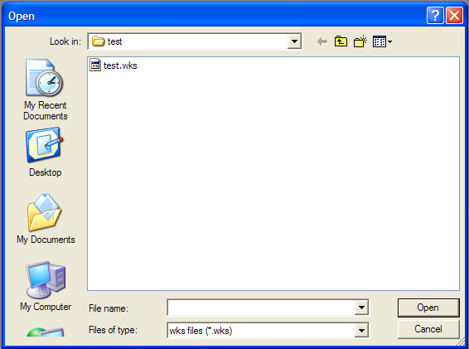

Creating a New Workspace:

Selecting “New Workspace” will bring up the following form. Control to the desktop will be blocked until you select DONE or CANCEL. In the name text area type in the name of your new workspace. In the FOV text area enter the Field of View of the camera used to take the photographs that you plan to add to the workspace.

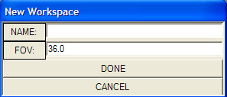

Saving the Workspace:
Whenever there is an active workspace it is possible to save it. Simply selecting “Save Workspace” from the File menu will create a WKS file with the name of the workspace.

Adding an Image to the Workspace:

Now that a workspace is active it is possible to add images to the workspace. This is done by clicking “Image” in the desktop’s main menu and selecting “Add Image”. The form below will pop up and control will be blocked from the desktop.

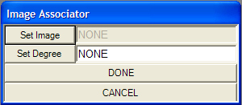

Clicking “Set Image” will trigger the display of a file chooser. The supported formats are JPG, GIF, and BMP. The path to the file chosen will be displayed in the text box to the left of the “Set Image” button. Clicking “Set Degree” will test the text written in the text box to the left of the “Set Degree” button and verify that it is a valid degree. Decimal values are acceptable in the “Set Degree” text box. Clicking done will open the image and make it ready for data input.

Once there is at least one image associated with the workspace the View menu on the desktop will become enabled. Clicking this menu will activate the “Images” window which displays all of the images associated with the workspace. Clicking on an entry in the window will activate its corresponding image container.

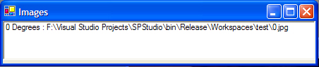

Image Container Controls:

When an image container is in focus two new menu options will appear in the desktop’s main menu. “Edit” will allow you to re-assign the image and degree associated with the container, or remove the image from the workspace entirely. “Mode” switches the image container’s input method between add and edit.

Add Mode Controls:

Left-Clicking the mouse will result in a point being entered on the image. A rubber band line will connect that point to the current mouse position. Continuous Left-Clicking results in a series of connected lines. It is up to you as a user to silhouette the target object using these lines. Right-Clicking the mouse will create a line connecting the last point entered with the first point entered. Pressing the ESC key will remove the last point entered. You can continue to press the ESC key until all of the points you added are gone.

Edit Mode Controls:

Left-Clicking and holding a point will allow you to drag the point around the image. Pressing the ESC key will remove the point from the image.

An image container with all data entered is shown below.

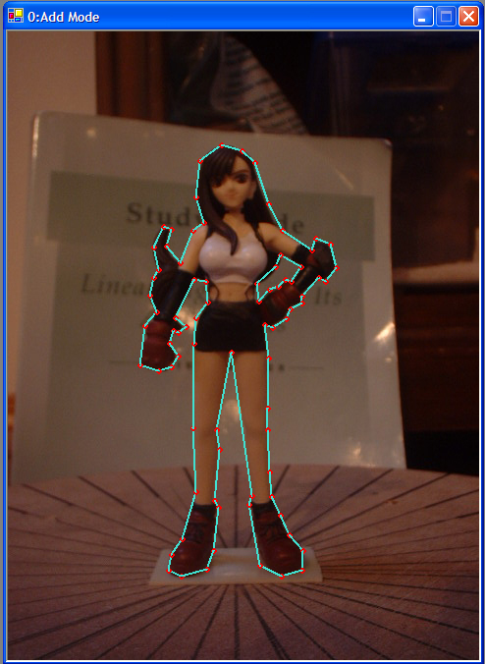
Running the Algorithm

In order to run the algorithm there must be at least four images. One image must be taken between 0 and 90 degrees, the next between 90 and 180, then next between 180 and 270, and last between 270 and 360. Once this is true the “Run Algorithm” menu button will become enabled. If there are images associated with the workspace that has not been given any silhouette data then you will be told which images and asked to complete the data entry process before continuing. If the previous conditions have been met then the following form will be displayed.

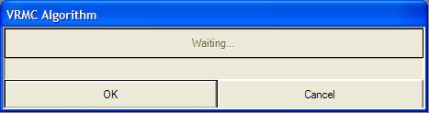

Clicking OK will run the algorithm. You can press Cancel at any time to stop the algorithm and return control to the desktop.

Shift Phase

Once the algorithm has completed the Shift Voxel View, and Shift Forms will appear. The Shift menu item on the desktop will become enabled. Should you choose to close either the Shift Voxel View or the Shift Form they can be recalled by clicking the Shift menu item on the desktop.

When the Shift Voxel View window is in focus there will be two menu items added to the desktop. “Isolate” allows you to select combinations of the four data sets to view as points in the color specified. “Intersect” allows you to view the intersection of the checked regions as red solid cubes. Below is the Shift Voxel View with isolation set for region 1 and region 3, and the intersection set for region 1 and region 3.

Both the Shift View and Voxel View will share the same keyboard commands.
W: Rotates Up by 10 degrees.
A: Rotates Left by 10 degrees.
S: Rotates Right by 10 degrees.
Z: Rotates Down by 10 degrees.
I: Moves view Up by 1 pixel.
J: Moves view Left by 1 pixel.
K: Moves view Right by 1 pixel.
M: Moves view Down by 1 pixel.

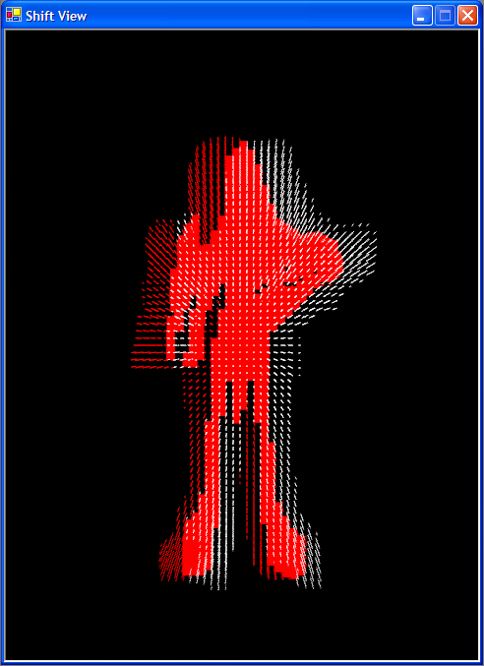
Using the Shift Form you can move each of the 4 regions one cube at a time. The purpose of this phase is to obtain the optimum intersection between all 4 regions. A good technique is to isolate pairs of regions and attempt to improve their intersection. Continue for all pairs until the intersection of all 4 regions reasonably represents the target object in the photographs. The Shift Form is shown below.

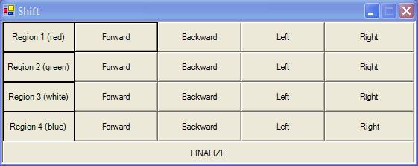

Once the intersection of the regions is satisfactory with you then it is time to press the FINALIZE button. The cubes that are found to be in all 4 regions will be recorded and shown in the Voxel View window. Should you choose to save your workspace at this point it will generate a MDL file that can be loaded later from the file menu. Below is the Voxel View for the demo figurine and a photo of the original.
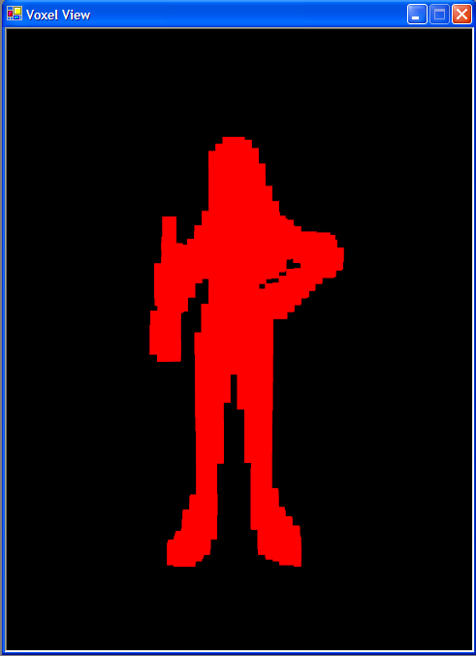

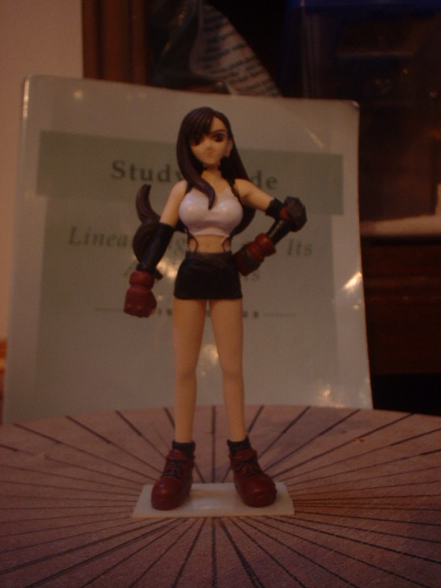

Appendix B: Code Listing

AssemblyInfo.cs

Desktop.cs

FileHandler.cs

ImageAssociator.cs

ImageContainer.cs

ImageList.cs

Line2D.cs

Line3D.cs

NewWorkspaceForm.cs

OpenGLPanel.cs

Renderable.cs

ShiftForm.cs

ShiftVoxelView.cs

Triangle3D.cs

Vector2D.cs

Vector3D.cs

VectorMath.cs

Voxel.cs

VoxelView.cs

VRMCAlg.cs

Workspace.cs

