UAA Self-Guided PDA Campus Tour

Edward Wickham
CS 470 Project Document

April 26, 2004
Table of Contents

Abstract 1
1. Introduction 1
2. Project Overview 1
2.1 Existing and Similar Services 1
2.1.1 UAA Orientation Department Guided Tours 2
2.1.2 Museum Self Guided Tours 2
2.1.3 Student PDA Tour Projects 2
2.1.4 Annotate Space 2
2.2 Evaluating Similar Solutions 3
2.2.1 Wireless Solutions 3
2.2.2 Off-Line Application Evaluations 4
2.2.2.1 The Nature of the Delivered Content 4
2.2.2.2 PDA Technical Considerations 4
2.3 Choosing a Solution 5
3. Project Requirements 6
4. System Design 6
4.1 Web and Application Servers 6
4.1.1 Web Server – Apache 2 7
4.1.2 Application Server - ColdFusion MX 7
4.1.3 Web server hardware 8
4.2 AvantGo Channel Configuration and Functionality 9
4.2.1 AvantGo Channel Setup 9
4.2.2 AvantGo Functionality 11
4.2.2.1 HTML Compression 11
4.2.2.2 Graphics Format Conversion 11
4.2.2.3 PDA Configuration Transmission 12
4.2.2.4 Multi-Platform support 12
4.3 Database development 13
4.3.1 Data relationship tools 13
4.3.2 Generalizations 13
4.3.3 Database schema drawings 14
4.3.3.1 Building schema relationships 14
4.3.3.2 Map Schema relationships 15
4.3.3.3 Services Schema Relationships 16
4.4 ColdFusion Application Development 17
4.4.1 The Map Grid 18
4.4.2 Common Dynamic Page Construction 19
4.4.2.1 Processing AvantGo Headers 21
4.4.2.2 Data Pages 22
4.4.2.3 Navigation Controls 25
4.4.2.4 Display Pages 26
5. Software Development Process 28
5.1 Palm OS Emulator (POSE) 28
5.2 Graphics Slicing and Creating Maps 29
5.3 Database evolution 29
6. Results 30
6.1 Final Program 30
6.2 Future Steps 32
7. Summary and Conclusions 32
8. References 33
Appendix A: User Manual 34
Introduction 34
Getting the Tour onto your PDA 34
Pre-Tour Task: Configure the Browser 35
Starting the Tour 36
Using the Maps 38
Viewing the Details 39
In Closing… 40
Appendix B: Code Listings 41
agHTTPHeaders.cfm 41
menubar.cfm 42
services_data.cfm 43
services_detail_data.cfm 45
services_summary.cfm 45
map1x.cfm 48
map111.cfm 49
Appendix C: Database Schema 51

Abstract

Prospective students and their parents often have few choices when it comes to finding their way around the UAA Campus. The University runs an Orientation Program, but these are limited by scheduling, cost and scope. An alternative to this program is clearly needed. Utilizing the growth in popularity of Personal Digital Assistants, this project, the UAA Self-Guided PDA Campus Tour, is a prototype application to allow any individual with a PDA the opportunity to download this application and conduct their own tour. The Tour provides both visual and textual information, and is constructed to allow the user to begin their tour anywhere and go in any direction they desire.

1. Introduction

This project was developed for UAA at the behest of Chief Information Officer Rich Whitney, in cooperation with Dr. Kenrick Mock of the Computer Science division within the Mathematical Sciences Department. After seeing some PDA based Self-Guided Tours offered by some leading museums, Mr. Whitney wanted to explore the possibility of developing a similar PDA based tour for the UAA Campus. Dr. Mock was to act as the primary stakeholder for the project.

2. Project Overview

The goal of this project is to develop a platform-neutral prototype for a portable self-contained self-guided tour of the UAA Campus. The application also needs to be constructed such that content management is easily performed by someone without a great deal of programming skill, although HTML experience can be assumed. The project not only needs to be concerned about the functionality of the PDA application itself, but also be concerned with how the application is distributed. While it was initially proposed that the tour would be distributed on University owned PDAs, it is desirable that any individual with a PDA can download and run the tour themselves.

The scope of this report is limited to the technical details of the application, its database and the mechanisms for delivering the application.

2.1 Existing and Similar Services

One of the first steps in any project is to look at existing related products and services. Perhaps the most relevant related local product is the Guided campus tours given by the Orientation department at the Campus Center.

2.1.1 UAA Orientation Department Guided Tours

UAA’s Orientation department (http://www.uaa.alaska.edu/orientation) offers scheduled Orientations in 2003. These include six Half-Day, eight One-Day and two Two-Day/Overnight Orientations. There is also one orientation geared for Graduate Students and one for ‘Non-Traditional’ Students. The current schedule runs from April through August, with the majority occurring between the end of a Spring Semester and the beginning of the following Fall Semester. Only the Two Day Orientation and the ‘Non-Traditional’ Orientation included any type Campus or Department Tour, while the One Day Orientation focuses on helping the student get settled into housing as well as academic planning. Additionally, these tours cost each student from $20 (Half-Day) to $75 (Two-Day Orientation with Housing).

While the project is not presented in terms of there being a pressing need for a self-guided campus tour, it is clear from the current state of Orientation that there is an opportunity to fill a rather gaping niche by providing a low-cost (potentially free) more complete self guided campus tour.

2.1.2 Museum Self Guided Tours

The Tate Museum in London, England began the first phase of an experiment during 2002 in which it created a Multi Media Tour (MMT) beamed to wireless Pocket PC (iPaqs) PDAs with wireless equipment that could sense where someone was located within one of the exhibits at the museum. A central server provided information (in the form of stored audio and video files) in real time. In this way, only a nominal amount of memory was used by the MMT. The experiment was successful enough so that they are in a second phase with newer, more capable PDAs.

2.1.3 Student PDA Tour Projects

Students at the New Media Institute at the University of Georgia created PDA projects similar to a Campus tour. Many of the 2002 and 2003 projects listed on the Institute’s web site (http://www.nmi.uga.edu/projects/) were implemented on Pocket PC type devices, all working within a wireless neighborhood in Athens, Georgia. Much can be learned from studying the user interfaces of the projects, and their approach to graphics and other content.

2.1.4 Annotate Space

Annotate Space (http://www.panix.com/~andrea/annotate/) was a project in 2002 by Andrea Moed as part of the Interactive Telecommunications Program at New York University. Her project was to provide a self guided tour of an area referred to as DUMBO (Down Under the Manhattan Bridge Overpass), an area of rich historical significance in New York. She discussed many topics similar to a UAA Campus Tour. For example, she highlighted the difference between linear tours (begins at point A, ends at point B) versus an active tour, where the user chooses where they enter the tour and which points to investigate.

She evaluated three different use cases, which included wireless delivery to a PDA, a wireless phone ‘walking’ tour, and a tour that was downloaded to a PDA. In the last scenario, she not only provided information about the sites she chose to include, but she also provided an interactive game that allowed the user to explore outside of the content of the tour. She also chose to allow the user to include .mp3 files with commentary from neighborhood people she interviewed. For those with PDAs without audio capacity, she provided a transcript of the commentary.

She chose to deliver the application using AvantGo’s Channel Technology for two primary reasons
- The AvantGo technology is web-based (a small web server and browser are downloaded to the PDA) development and delivery time could be accomplished quickly using HTML and JavaScript.
- The AvantGo technology is cross platform, which means that any PDA could display the tour, regardless of the OS.

2.2 Evaluating Similar Solutions

2.2.1 Wireless Solutions

While not dismissing a feature rich, multimedia tour for the UAA Campus out-of-hand as a possible solution, the reality is that the wireless infrastructures that exist at the Tate Museum and surrounding the University of Georgia do not exist to as great an extent at UAA. While there are wireless hot-spots in several locations on the UAA Campus, the service is still very new. There are plans to expand the network to cover more of the campus, but complete coverage of the campus is still years away. With the limited wireless capacity currently available, it does not seem practical to design a solution around a service with an uncertain delivery timeframe.

Additionally, it is unclear as to whether or not the Campus wireless network (as planned) would be able to geographically locate an individual device so that it can be correlated to an existing map. An option for identifying an individual’s location would be using Global Positioning Satellites (GPS). While there are GPS devices available for some PDAs, these tend to be relatively expensive (approximately $150) and are not as prevalent among PDA owners. The existing Anchorage Bowl wireless phone network is similarly not capable of generating the map coordinates of a wireless phone.

Finally, there is also no budget to purchase wireless PDA devices for testing.
If wireless product delivery is not a viable option, then off-line options must be evaluated.

2.2.2 Off-Line Application Evaluations

The fundamental questions that must be answered when considering an off-line application are:
- How will the content be delivered?
- What application will display the content?
- How can different PDA OSes be accounted for?
- How can different PDA display screens be accounted for?
- How can limited PDA resources be overcome?

2.2.2.1 The Nature of the Delivered Content

The data proposed for the Self-Guided tour is by and large static. Campus maps, information about departments, buildings and their history, locations of services and landmarks evolve slowly. There will be times when content will need to be added or modified, but this in no way lends any real dynamic nature to the content.

2.2.2.2 PDA Technical Considerations

There are several key limitations presented by the delivery platform, the PDA. First, there are two primary and very different types of PDA Operating System (OS). The first is the Palm OS, which appears on Palm, Sony, Handspring (a extension of the Palm OS), and a few other manufacturers’ PDAs. It has been estimated approximately 70% of all PDAs run the Palm OS. On the flip side are PDA devices known as Pocket PCs, which run a variant of the Windows operating system, Windows CE. Because the target of the project is to hit PDAs in general, and due of the disparity in Operating Systems (OS) used by these devices, writing an application specifically for one OS is not an optimal solution.

Another limitation of the delivery platform is the resolution of the display. The smallest resolution in common use is the 160 X 160 pixel layout of most Palm-based PDAs. The newest generations of Palm PDAs have 320 X 320 16 bit color displays (65,536). While the Pocket PC screen is larger at 240 X 320, it is a prudent design decision to work the smaller screen size as the least common denominator. Another screen factor is color display capability.

While a growing number of new PDA screens are color (approximately 72% in 2002) there are still a sizeable percentage of monochrome displays. Monochrome displays have either a 4 (2 bit) or 16 (4 bit) grey scale. To maximize the use of the Self-Guided tour, it would be useful if we could present color graphics where possible, but allow for well rendering grey scale images for monochrome displays.

The final major limitation of PDA delivery is that the majority of them operate in an ‘off-line’ mode as only about 19% of PDAs offered wireless on-line functionality in 2002. That is, the majority of PDAs are not connected (wirelessly or otherwise) to the Internet. There is only limited wireless internet service available on the UAA campus, and while this service may be extended to most areas of campus, there is no expectation that the service will be available everywhere. This means that any solution will have to be self contained, since it there will be no reliable interaction between the PDA and any external resource.

2.3 Choosing a Solution

After careful consideration of the all the options available and the restricting timeline for product delivery, I choose to delivery prototype PDA Self Guided Tour as an AvantGo Web Channel. This solution provides the following advantages:

- With the content in HTML format, prototypes are quickly and easily constructed, tested, and deployed.
- HTML makes the content more maintainable.
- The application will be viewable by any type of PDA. Additional devices may be added as support for them from AvantGo is added.
- An individual can download the tour to their own PDA and conduct the tour without any additional University resources.
- AvantGo Channel service knows what type of PDA device a user has, and can provide content and graphics best suited to the PDA.
- AvantGo has tags to utilize server caching, which helps minimize the impact to the host server.
- AvantGo has tags that help the web site customize PDA appropriate graphics and content.

3. Project Requirements

- Palm or Pocket PDAs are the primary user platform
- The Tour will provide Campus maps with detail appropriate to scale
- The Tour will provide information about
  - Buildings
  - Departments
  - Points of Interest
  - Parking
  - Shuttle service
  - Food
  - Campus Security
- The tour will provide both factual and anecdotal content.
- The tour should be able to address the following types of questions:
  - Where am I?
  - What is this building?
  - Where is the Theater department?
  - What is this building’s hours?
  - Where are the handicapped entrances?
  - How do I get there from here?
  - Where do I register?
  - What’s the story behind the artwork here?
  - Who do I contact for more information?
  - What Departments are in this building?
- The Tour will provide for an ‘active’ campus tour. That is, the user can enter the campus at any point and begin their tour from there.
- The Tour will provide hints as to what areas are nearby to explore.
- Tour information must be easily maintained and appended.

4. System Design

There are four related components to this design
- Web and Application Server Implementation
- AvantGo Channel Configuration and Functionality
- Database Design
- ColdFusion Application design

4.1 Web and Application Servers

4.1.1 Web Server – Apache 2

AvantGo serves as a web-content broker, so for this application to be delivered via AvantGo meant that there needed to be a web server to render the content. For the purposes of this project, this was the web server’s only purpose. In the world of today, with spammers and web-site hijackers, it was important to me that the server be as secure as possible, while allowing AvantGo servers to retrieve data and for me to remotely access the content for development.

For no reason other than knowing that there are many security holes in Microsoft’s IIS servers, I chose Apache for Windows. While it generally takes more to configure this server properly, this Open Source web server is generally considered more secure.

The key to creating the needed web security was in modifications to the web configuration file, http.conf, which includes access control as part of its many parameters. The relevant section of the configuration file follows:

<Directory "C:/Program Files/Apache Group/Apache2/htdocs">
Options Indexes FollowSymLinks
AllowOverride None
Order deny,allow
AuthType Basic
AuthName "Restricted Directory"
AuthUserFile "c:/program files/Apache group/apache2/passwd/passwords"
Require valid-user
Allow from avantgo.com
deny from all
Satisfy Any
</Directory>

Code Snippet 1 – Web Server http.conf security

This section sets the permissions for the root of the web server. By default all access is denied (Order deny,allow), except for any request coming from the avantgo.com domain (Allow from avantgo.com). Domain level access was necessary because there are many server in the avantgo.com server farm that might request access, and setting IP specific access seemed onerous. My personal access to the site is controlled by ‘Require valid-user’ which utilizes the AuthUserFile to authenticate my username and password.

My web server also sits behind a firewall, so a rule had to be added to allow passing all port 80 requests to the firewall’s IP address to the web server’s internal IP address.

4.1.2 Application Server - ColdFusion MX

The choice of ColdFusion MX as the application server for the project was based on two criteria
- My past experience developing ColdFusion applications as an employee at GCI.
- Knowledge that the UAA Information Services department develops all of the official UAA websites using this technology, and would be able to support this and future versions.

An additional feature of the ColdFusion server is its Remote Development Service. This service allows my Macromedia Dreamweaver development environment to remotely publish content. This is an additional security layer on top of what the Apache 2 server provides.

There is one configuration setting necessary in the ColdFusion server. There is a ‘Mappings’ section within the ColdFusion administrator, which allows a developer to map a logical directory name to a physical file system address. Server mapping is an alternative to relative file mapping. Relative file mapping is a brittle mechanism, since it requires that the relationship between directories to remain constant. This is not a realistic expectation in web architecture, since applications are constantly being modified.

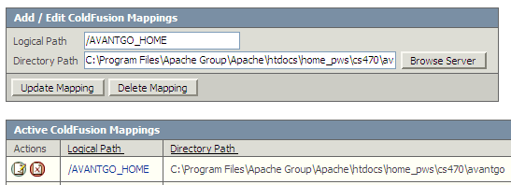
Figure 1 - ColdFusion Service Mapping

From an application development standpoint this technique is useful because not only does it allow the application to be decoupled from the physical deployment but it also helps to guarantee that the ColdFusion server will be able to consistently locate files.

4.1.3 Web server hardware

The web and application server is running on a computer with the following attributes

OS: Windows XP Professional
Processor: Pentium III, 600 MHz
RAM: 512 MB
Disk Capacity: 20MB

These attributes should not to be construed as minimum requirements – they merely reflect hardware I had available to me for development.

4.2 AvantGo Channel Configuration and Functionality

4.2.1 AvantGo Channel Setup

AvantGo Channel configuration is quite simple. After my personal account was set up on their site (www.avantgo.com), I was given 2MB of capacity to create my free channel. Since I wasn’t going to need more than this for developing the prototype, this was more than adequate. Additionally, I am only allowed up to 8 others subscribing to my channel before AvantGo start to charge. The fee for 9 to 999 subscriptions is $1,000. Since there is no other budget for this venture, I’d better keep the number of subscriptions to below 8, and I hope this doesn’t compromise the level of field testing I’ll be able to perform.

AvantGo has different product offerings for large Businesses, starting at $10,000. The capabilities of these products far exceed the development platform I received with my personal account, including storing an XML ‘database’ on the PDA, with extended browser and server capabilities. I did not develop this application for the Business product.

There are only a few settings that require definition for the site to become functional.

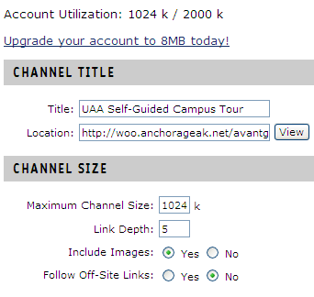
Figure 2 - AvantGo Channel Set up

First, a title is chosen and then a fully qualified URL is given for the location of the web server containing the content to be published. URL variables can be included here, and there are AvantGo specific SYSTEM variables that can be added. However, since the information AvantGo sends in the HTTP GET header (discussed in the ColdFusion Application Development section) it seemed unnecessary to me to include any URL variables.

Determining the Channel size was a little more trial and error, since as the application and the size of its related graphics files grew, so did the size of the Channel. While the current maximum size of the site is well under the 1024KB listed here, I left some headroom for the channel to grow as additional content is added through the Database.

Perhaps the most interesting configuration attribute is ‘Link Depth’. AvantGo extracts content from a web server by following HTML links in a series of HTTP GETs. This is often referred to as ‘spidering’. Link Depth tells the AvantGo servers how many layers of pages to traverse to collect its pages, as illustrated in Figure 3, from AvantGo’s Developer’s Manual.

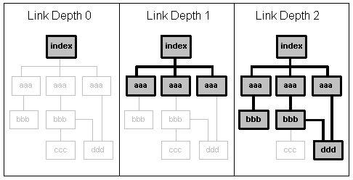
Figure 3 - AvantGo Link Depth

As the application site grew in complexity, this attribute had to occasionally tweaked to ensure that all the content and all the links migrated properly from the application server to the AvantGo Website.

While not particularly applicable to the development of a prototype, AvantGo also has attributes that affect how their servers cache your information. Additionally, there are HTML META tags that can be added to content to refine the caching scheme. During development, I found it useful to leave the setting at ‘on every sync’ since content was changing frequently. Figure 4 shows this portion of the Channel configuration. As the content stabilized, this setting was moved to its current setting.

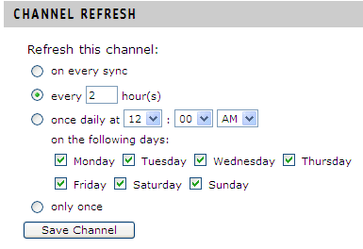
Figure 4 Avantgo Channel Caching

4.2.2 AvantGo Functionality

AvantGo provides very interesting functionality for channel building.
- HTML Compression
- Graphics Conversion
- PDA Configuration Transmission
- Multi-platform support

4.2.2.1 HTML Compression

AvantGo helps to reduce the memory footprint on PDAs by compressing the HTML it receives from content web servers. It does this in a number of ways, but a primary way this is achieved is by discarding any HTML tag or attribute that it does not support.

4.2.2.2 Graphics Format Conversion

AvantGo is capable of converting graphics formats on-the-fly. Since the server knows the graphical capabilities of the PDA requesting the content, it can, for example, convert from color to grayscale and from 8 bit to 4 bit on the fly. This means that should a developer choose, they could develop a site with only one set of graphics and could let the AvantGo servers convert the graphics for them. I chose not to give up this rendering control, and chose to implement separate graphics directories for differing formats and resolutions.

The AvantGo does not resize graphic image, however. In a related note, image HEIGHT and WIDTH IMG HTML attributes that are not even supported. Additionally, AvantGo will not download a graphic larger than the maximum resolution the browser can support.

4.2.2.3 PDA Configuration Transmission

When sending HTTP GETs to the hosting web server requesting content, the AvantGo server sends along information in the HTTPHEADER that describe many attributes of the requesting device. This allows the developer, should they choose, to customize the returned content. A partial list of attributes is shown in Figure 5.

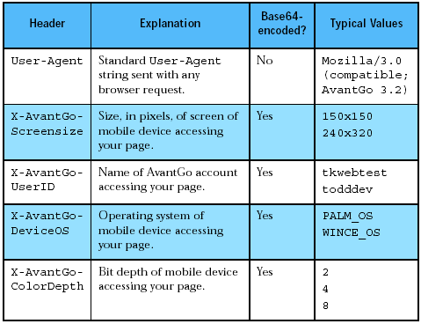
Figure 5 - AvantGo HTTP Header Fields

It seems odd to me that AvantGo chose to Base64 encode information like ColorDepth, DeviceOS and Screensize, since the values in-and-of-themselves contain no meaningful personal information. The key pieces of information that I used in developing my application were Screensize and ColorDepth. Since I chose to make the application platform-neutral, this meant that any differing capacities offered by different OS platforms needed to be ignored.

4.2.2.4 Multi-Platform support

Currently supported devices are:
- Palm OS
- Pocket PC
- Windows CE
- Symbian OS (Nokia cell phones)
- RIM Blackberry (Blackberry devices)

Even though this application was developed primarily for Palm OS and Windows CE devices, it is exciting to realize that AvantGo is capable of delivering more. Porting this application to Symbian cell phone or a Blackberry device is relatively simple. All that is needed is to evaluate the graphic capacities of these devices and either map existing graphics directories or create a new directory with graphical elements.

4.3 Database development

The realization that I was going to need a database to support this application came during the development process when I realized that there was just too much data to organize and manage through a completely static HTML site. Because of this late realization, I chose to develop the prototype database in Microsoft Access 97, for no reason other than it was available to me and I had some experience with it.

4.3.1 Data relationship tools

Starting with the initial requirement that there needed to be information about Buildings, Departments, Services, and Points of Interest as well as maps to provide a visual component of the tour, the following schema developed. The application DeZign for Database V3 by Datanamic was used to do the early visual schema development. This application was then able to forward engineer the database and all its constraints to Access 97. I would not recommend Access 97 for a production environment, but would suggest porting the schema to a more scalable database such as Oracle or SQL Server.

4.3.2 Generalizations

There are many tables in this database that have a similar construction and meaning, so I will discuss them once and spend the balance of the database design discussion explaining the relationships between the different components.

There are primary data tables and several associative tables, which are used to manage many-to-many relationships. The primary tables all have a single primary key. Whenever possible, such as for Buildings, Departments and Schools, I reused UAA abbreviations for these items. For example, the Engineering Building has an accepted abbreviation ENGR and this as the building’s primary key. Another example is the Dance departments, which uses the abbreviation DNCE.

When constructing the POI_TAB (Points of Interest) and SERVICE_LOCATION_TAB table, I discovered that there were not any existing accepted abbreviations for these types of items, so an Auto-Indexing integer value was used as the primary key.

Each primary data table also has a NAME and a DESCRIPTION field. The NAME is a 64 character field and the DESCRIPTION field will allow up to (approximately) 65,000 characters. This is more than adequate for the task at hand.

In fact, this may allow for too much content, considering that the maximum number of characters that can appear on any given page on a PDA is approximately 350 words. Too much data could create displays that would require the end user to scroll through 5 or 10 pages just to read the entire content. For conciseness, I would recommend keeping any description to 100 words or less.

4.3.3 Database schema drawings

Rather than present the entire schema, I have chosen to present portions of the schema, relevant to the areas under discussion. The entire schema will be included in Appendix C.

4.3.3.1 Building schema relationships

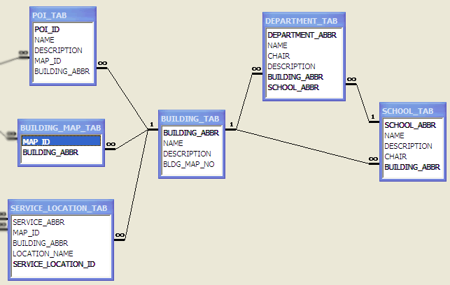
Figure 6 Building Schema

The first database construct concerns Buildings, since they are the most visible object to tourists, and that they act as containers for many of the other constructs, such as Departments and Services. Buildings related schema is shown in Figure 6.

Buildings by themselves have very few attributes to be concerned with
- Building Abbreviation
- Name
- Description
- Building Map Number

The Building Map Number is the number used to identify the building on the map chosen for this application.

The primary key for the BUILDING_TAB, BUILDING_ABBR is a foreign key in other tables. It is required in some tables, like the SCHOOLS_TAB and DEPARTMENT_TAB, while it is a reference foreign key in others, such as the SERVICE_LOCATION_TAB and POI_TAB.

What is meant by a reference foreign key is that the value for this field in the host table is not required and may be null. However, if the field has a value, it is required to be in the BUILDING_TAB. Services are a good example of this. A service, such as Dining, exists in a building, while another service, Shuttle, doesn’t. However, if a service is in a building, I want to ensure that the BUILDING_ABBR exists in the BUILDING_TAB.

The primary key is also part of an associative table, BUILDING_MAP_TAB, where it is part of a two-part primary key along with MAP_ID. This table helps to manage the somewhat arbitrary way that buildings on campus maps may get sub-divided onto more than one map. This table allows for the map grids to change while still maintaining the integrity of the application.

4.3.3.2 Map Schema relationships

Maps presented a challenge because I chose to represent UAA Campus maps in a 2-square grid at varying layers of detail. (I’ll discuss this decision in more depth when I discuss the application design). The MAP_ID is a number that directly corresponds to the map grid and map ‘depth’. The Map schema is illustrated in Figure 7.

When constructing the application, it became apparent that there was some difficulty logically representing how maps at depth=2 (the highest level of detail) related to map grids at depth=1 (intermediate detail level). I resolved this by adding a column SUMMARY_MAP_ID to MAP_TAB, so that I could know how to correlate a map depth with the Buildings, Departments, etc. that might be represented on the map. I thought about parsing the map file name to determine the correlation, but this solution seemed even more brittle than the SUMMARY_MAP_ID solution. I do not believe this is the most elegant solution to the correlation problem, and I would recommend revisiting the solution in future development efforts.

How maps are described is another area that will need addressing in future iterations. While at the lowest level of detail (depth = 0), the map descriptions could easily be named ‘East Campus’, ‘West Campus’, ‘Housing’ and ‘Off-Campus’, it became more difficult to come up with good descriptive names that represented the sub-divisions of these areas, which represent intermediate and full detail levels. Describing a map by referencing its location in the grid is too abstract, and adds no user-meaningful information.

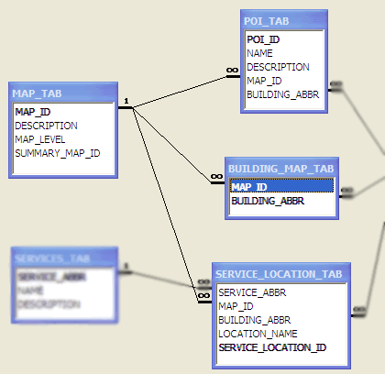
Figure 7 - Maps Schema

4.3.3.3 Services Schema Relationships

The Services schema (Figure 8) was unusual because of the unique nature of the distribution of services about Campus. Not only could there be multiple instances of the same service on various maps, such as Dining Services, but there could also be multiple instances of the same service on the same map. The Emergency Phones in the Southwest corner of campus is a good example of this. A service could be in a building, it could be outside, and sometimes could be both, as is the case with the Parking Garage.

This meant that there would need to be up to three unique identifiers for any particular Service when describing the location of the service in the SERVICE_LOCATION_TAB. Not only would I have to indicate the nature of the service and whether or not it was in a building, but I would always have to note which map it was on, even if it was in a building. This was a good candidate for duplicating MAP_IDs for Building-Located services (the MAP_ID could have been derived through the BUILDING_ABBR and the BUILDING_MAP_TAB) but since the MAP_ID was already needed for those services not in buildings, there seemed to be more to gain in ability to create easier SQL than there was to risk by the off-chance that there could be conflicting MAP_ID information. This could be mitigated by creating a more complex dual foreign key relationship between the SERVICE_LOCATION_TAB and the BUILDING_MAP_TAB, and this may be a more robust solution for future development efforts.

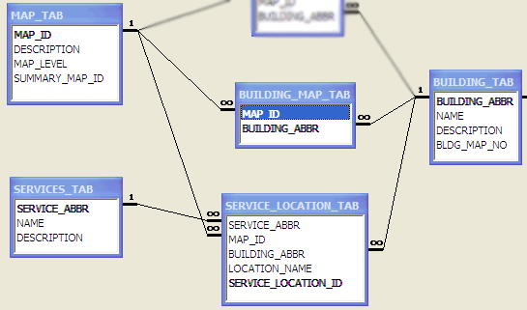
Figure 8 - Services Schema

4.4 ColdFusion Application Development

This application was initially conceived as a collection of static HTML pages. Since my original analysis showed that most of the information being presented was by-and-large static that a carefully crafted set of HTML templates could be used to present all the data.

However, as I began to uncover the true nature of the relationships between the primary data components (Buildings, Services, Departments, Points of Interest and Maps), it became clear that a completely hard-coded solution was not going to achieve the requirement that the content in the application could be easily maintained. Additionally, I purchased as new Palm PDA with a higher resolution (320x320). Viewing the site designed for 160x160 on the new Palm convinced me that I was going to have to dynamically choose graphic files. I knew the application was going to have to be dynamically generated.

My first step was the development of the Database presented in the previous section. Once the Database came close to representing the relationships that I wanted to represent, it was time to build a dynamic application to organize and present the information. I have 5 years of experience using ColdFusion as a Software Engineer II at GCI, but at first glance, this application didn’t appear to be a traditional web application. After all, the AvantGo browser itself has little functionality save displaying standard HTML elements and there could be no dynamic page generation on the PDA itself.

Over time, experimentation led to the realization that the site harvested by AvantGo could be as dynamically generated as any other web-site. My only limitations were that the dynamic content could only be evaluated by the use of URL variables, which AvantGo would pass is with its HTTP GETs. I could, however, use ColdFusion to dynamically generate the URL variables and their values. This capability gave me the flexibility I needed to achieve the functionality demanded by the requirements.

4.4.1 The Map Grid

The Map grid was an early design feature needed to drive the visual tour component parts. The decision to go with a repeating square grid was driven mostly by the square display formats of Palm OS devices, since this type of device accounts for more than 70 percent of the market. The decision to use a ‘drill-down’ technique to present different layers of map details was driven by the limited resolution of these same Palm OS devices. The choice to use three different layers was done in an effort to get the end-user to a usable level of detail as quickly as possible. A generalization of the map scheme is illustrated in Figure 9

Small Scale Map Grid
Least Detail
Medium Scale Map Grid
More Detail
Large Scale Map
Most Detail
1
2
3
4
2.1
2.2
2.3
2.4
2.2.1
Figure 9 – Generalized Map Layout

While it was simple enough to devise an HTML table with links to ‘lower’ map grids, this drill-down functionality did not have as intuitive an inverse function. Taking a clue from other mapping applications, I decided to add a button to the navigation controls. The image used on this button – a magnifying glass with a “-“(minus) symbol is a generally accepted icon for zoom out functionality.

When at more detailed areas of the map, I realized that it would be inconvenient for the user to have to zoom-out and then zoom back in to move to an adjoining map grid. To solve this problem I chose to use ‘smart’ graphic arrows that allowed the user to navigate the maps independent of any other control at whatever detail level they were at. The arrows are smart in the sense that there is only an arrow on a map if there is an adjoining map.

The internal numbering scheme for the maps was chose to allow for future expansion. By adding a dot notation, I allowed for future expansion of the map, including a deeper layer of detail. For example, Map 1 points to Maps 1.1 through 1.4. Map 1.1 points to Maps 1.1.1 to 1.1.4. Map 1.1.1 points to Map 1.1.1.1 through 1.1.1.4, etc. This provides a convenient and consistent naming scheme for future developers.

A page representative of the code used in each of the 21 map pages will be presented in the Appendix.

4.4.2 Common Dynamic Page Construction

When you watch the AvantGo service spider the application web server for content, it is quite amazing to see that there are in excess of 330 pages being generated by this application. A count of actual pages (excluding graphics and database files) on the web server shows that there are only 48 pages, 21 of which are map layout pages. This leaves 27 pages generating more than 300 pages of content.

Seventeen of these pages are the heavy lifters in this application, responsible for the generation of the vast majority of the application’s pages. Each of these heavies has a similar construction to efficiently and predictably construct content. These primary components are

- AvantGo HTTP_HEADER Processing (1 page)
- Data Extraction (8 pages, 2 for every data category)
- Navigation Controls (1 page)
- Layout Code (8 pages, 2 for every data category)

Figure 10 shows a simplification of how all these four components are related to construct all of the dynamic content and display pages. I’ll first present an overview of how the page processing works, and then I’ll go into more detail with code examples in subsequent sections.

When the application host web server receives a request for a ColdFusion page (files with a .cfm extension), this request is passed on to the ColdFusion server for processing. The ColdFusion server assembles the page and its components and then proceeds to process form and URL variables, execute proprietary functions, perform database queries, and build dynamic content. The ColdFusion server returns HTML to the web server, who returns this to the client.

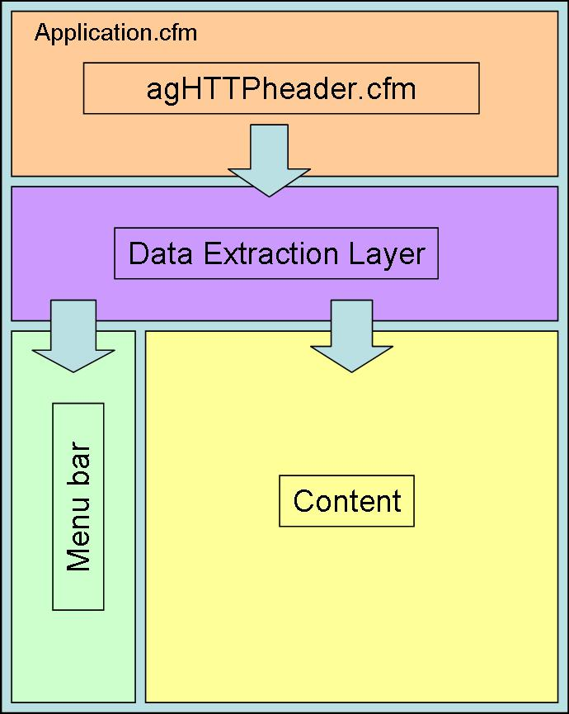
Figure 10 - Common CFML Page Architecture

The heart of the page construction assembly is the ColdFusion tag CFINCLUDE, which takes code from a referenced file and includes in the current file as if it were written there. This means that the included page can reference variables in the same scope as the rest of the page, and vice versa. A special ColdFusion page that performs a function similar to this is called Application.cfm.

Designed to contain application-wide declarations and functions, Application.cfm is auto-included (that is, without being explicitly referenced) at the beginning of every .cfm page construction. This feature allowed me to have a single file where I could place application critical functions and processing. For the Self Guided Tour, I perform two primary functions in the Application.cfm page:

- After determining the host web server name, I set a variable that indicates the URL root for the application. This gives me the flexibility of consolidating all my graphics files in a single directory. This allows me to reliably get to my graphics files from anywhere on the site, regardless of sub-directory depth. This is different from the ColdFusion Application Server mapping, since the value here a URL, not a file mapping. Some tags within ColdFusion require a file mapping, while others, like IMG require a URL mapping.
- Process the AvantGo information in the HTTP request header, and use this information to determine in real time which graphics directory to use when returning graphic files to the client.

Processing is passed on to the Data Extraction Layer where URL variables are assessed to determine which query is executed and then used again to construct dynamic SQL. The graphics information, the URL variables and any resulting query data are now available to menubar and the content layout pages. All of this information is dynamically combined to generate the HTML output returned to the web server.

In the following sections I will present code sections relevant to discussing the architecture of the application. In Appendix B I provide the full code for the pages mentioned, which are representative of all the major processes.

4.4.2.1 Processing AvantGo Headers

Extracting the client PDA information from the AvantGo HTTP_HEADER and preparing it for use by the rest of the application proved to be relatively straightforward. The major steps were to

- Extract the raw HTTP_HEADER from the full HTTP_REQUEST
- Decode the Base64 Encoded information
- Create a decision tree using the information

There is a single page which performs all three of these functions, called agHTTPheaders.cfm. By being included in the Application.cfm page (which the ColdFusion server processes first on any .cfm page request) I was able to guarantee that this page would be run with out fail.

agHTTPheaders.cfm
After creating a list of AvantGo variables I am interested in, I use a ColdFusion method called GetHttpRequestData(), to return all of the information in the HTTP request header. This method returns a construct referred to as a STRUCTURE. Using a list items as the of the data key, I loop over all the parts of this object, extracting those parts of the header I was interested in, and constructing local variables with the value matching the key.

Decoding the Base64 encoding is a two part operation, since ColdFusion hasn’t deployed a single function to do this decoding, unlike PHP or Perl. The string first has to be converted to from Base64 to binary, and then from binary back to a string value. The code loops through the headers, extracts the needed http headers, decodes the value and dynamically names and creates the local instance variable, as illustrated below

<cfloop collection="#x.headers#" item="http_item">
<cfif ListFindNoCase(avantGoParams, http_item) gt 0>
<cfset shortName = right(http_item, find("-", reverse(http_item)) - 1)>
<cfset temp =
SetVariable("Variables."&#shortName#,ToString(toBinary(StructFind(x.headers, http_item))))>
</cfif>
</cfloop>
Code Snippet 2 – Extracting AvantGo HTTP Header information

Subsequent to this section, I evaluate the values of ColorDepth, and ScreenSize to determine which graphics directory to use when referencing images. An additional Request scope variable, request.avantgo_home is added to the beginning of the actual image mapping. This variable is determined in the Application.cfm page, and provides a full URL mapping to the application root.

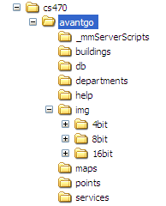  Figure 11 – Directory Layout | This is done to guarantee that I will always be able to correctly find graphics regardless of the number of sub-directories I might be in when I need a graphic. While the current application file structure (shown at left) has most of its primary directories off of the application root, there is no guarantee that this will always be the case. This technique allows me to reliably centralize all my graphics, while code accessing the graphics directory could move anywhere in the site.  The graphics directory value is stored in the variable variable.graphics_dir, as illustrated in the code snippet 3, below.

<cfcase value="16">
<cfif Variables.ScreenSize EQ "320x320">
<cfset variables.graphics_dir = "#request.avantgo_home#/img/16bit/320">
…
…
Code Snippet 3 – Setting Graphics directory

Armed with this information, we’re ready to begin processing the balance of the page.

4.4.2.2 Data Pages

There are two types of data pages within the application – summary data and detail data. In general, summary data is presented when looking at collections of a particular category. Examples might be a list of buildings in the West Campus or a list of Parking Lots on the entire campus.

While the page being called knows whether or not it’s a summary or a detail page, combinations of URL variables determine which query to use and which values to dynamically pass to the SQL. An illustrative example from the services_summary.cfm page (Appendix B) is shown in Code Snippet 4. I have removed some of the detail from this snippet to illustrate the evaluations

Services are a unique in this application in that summary information might be requested by location (e.g., map - indicated by URL.mapNumber) or by service type (e.g., parking lots – indicated by URL.svc). The default query returns all the services on the entire campus.

<cfif isDefined ("URL.mapNumber") and URL.mapNumber GT "1">

<cfif findnocase('x',URL.mapNumber) gt 0>
<cfset searchField = "summary_map_id">
<cfelse>
<cfset searchField = "map_id">
</cfif>

<cfquery name="getMaps" datasource="uaa_sgt">
. . .
</cfquery>

<!--- Get service information specific to this map --->
<cfquery name="getServices" datasource="uaa_sgt">
. . .
</cfquery>

<cfelseif isDefined("URL.srv")>

<!--- Get information about this service on all maps --->
<cfquery name="getServices" datasource="uaa_sgt" >
. . .
</cfquery>

<cfelse>

<!--- Get information about all services --->
<cfquery name="getServices" datasource="uaa_sgt" >
. . .
</cfquery>

</cfif>

Code Snippet 4 – Dynamically determining query to execute

There is a unique decision that needs to be made if a map summary is requested, and that is because of the way the intermediate map pages are constructed. If the outermost map layer can be considered layer 0 (zero detail), then the medium layer is considered layer 1 and the most detailed area is layer 2. Map pages at layers 0 and 1 are both four part grids, with the layer 1 grid showing maps linking to layer 2. The map numbering sequence, however, didn’t translate well to the file naming scheme, so the grid map for map 1 (West Campus) with links to layer 2 is named map1x. For the purposes of summarizing which buildings were on these four maps, a field was added to the MAP_TAB called the SUMMARY_MAP_ID, which is used to indicate which map a detail map summarizes into. This is why the mapNumber is scanned for containing an ‘x’, and if so, it creates the database query using the SUMMARY_MAP_ID field instead of the default MAP_ID field.

The very first evaluation demonstrates that ColdFusion does short-circuit evaluations when performing a logical ‘and’.

Perhaps the most daunting database task I faced during the construction of this application was understanding the syntax used by Access when creating different types of joins. I have a number of years of experience using various versions of Oracle, and have limited exposure to SQL Server, which is similar in syntax to Access. The syntax used by Oracle and Access for doing joins is very different, be they inner, outer, left or right joins (or any combination of the preceding). With the clock ticking and a very complex join situation presented by the services detail section, I turned to the Access SQL GUI.

Using the GUI, I graphically constructed the joins and the table relationships I wanted, and then confirmed it by running the query and checking the data output. Once the output was correct, I went the SQL panel, and copied the SQL statement Access had generated. I pasted this SQL statement into the ColdFusion code and made minor modifications (table aliases, for example) so that the query could respond in a dynamic environment. The following code snippet shows a final result.

<cfquery name="getServicesDetail" datasource="uaa_sgt">
select a.name, a.description, d.name as building, b.map_id, b.location_name,
d.building_abbr, c.description as location
from map_tab as c
inner join (building_tab as d
right join (services_tab as a
inner join service_location_tab as b
on a.service_abbr = b.service_abbr)
on d.building_abbr = b.building_abbr)
on c.map_id = b.map_id
where b.service_location_id= <cfqueryparam value="#thisSvc#" cfsqltype="cf_sql_varchar">
</cfquery>
Code Snippet 5 – Services Detail Query

What made this query so difficult to construct is that the main table being queried SERVICE_LOCATION_TAB has foreign keys with three other tables (MAP_TAB, SERVICES_TAB, and BUILDING_TAB) where the join to the BUILDING_TAB is an outer join. That is, the join, and its foreign key enforcement, only exist when there is a corresponding value in the SERVICE_LOCATION_TAB. If there is no value in the SERVICE_LOCATION_TAB, then the foreign key relationship isn’t enforced, a null value for the field (BUILDING_ABBR) is returned along with the rest of the record in the SERVICE_LOCATION_TAB.

I also chose to do something when constructing these queries which may seem a little risky. There is often more than one query on the data pages with the same name, although only one is executed at a time. Where there is more than one possible database query, I often return different sets of columns, depending on what the needs for the display page are going to be. This work was necessary because I wanted to keep the display page simple, which meant referring to a single named output dataset. I make this work by logically checking (in the display page) for the existence of the differing column(s) before outputting.

4.4.2.3 Navigation Controls

The purpose of the Navigational controls is to provide access to the different categories of information presented in the Self-Guided Tour in a consistent and structured way. To do this, the buttons need to be kept aware of the state of the application, and respond to user input in a straightforward and logical manner.

The Navigational Controls exist in two basic states
- Maps are being viewed
- Maps are not in view.

If maps are being viewed, then the links in the Navigational controls are constructed to keep track of the last map viewed. In this way, when a user is looking at a map, and decides they want to know more about the different things that show on the map, the user can then tap the Buildings, Services, Departments or Points Of Interest button in any order and display each category’s summary for the map that started the initial request. The Map button can even redisplay the original map.

<cfset showMapButton = "Y">

<cfif isDefined("url.mapNumber")>
<cfset mapNumber = #url.mapNumber#>
<cfelseif REFind("\/maps\/",cgi.SCRIPT_NAME) GT 0>

<cfscript>
thisFile = getFileFromPath(cgi.script_NAME);
mapGrid = listGetAt(thisFile,1,".");
mapNumber= right(mapGrid,len(mapGrid)-3);
if (mapNumber GT 1)
showMapButton = "N";
</cfscript>

<cfelse>
<cfscript>
mapNumber = "1";
</cfscript>
</cfif>

Code Snippet 6 – Setting and retaining the map number

There are two primary areas here. First off, if a URL map number exists, we retain it. If the URL variable doesn’t exist, we see if we’re in the maps directory by doing a Regular Expression check against the page name, which is stored in CGI variable named SCRIPT_NAME. If we aren’t in the maps directory, we set the mapNumber to 1 and continue. Also note that a flag is set to indicate that the Map button is shown by default, but that if we’re in any of the detail maps we do not show the Map button.

If we are in the maps directory, we go through the machinations of extracting the mapNumber from the file name, where it’s embedded as “mapXXX.cfm”. A ColdFusion function getFileFromPath returns the filename from the full URL. This filename is then treated as a period (“.”) delimited list. The filename is the first item on this list (the file extension is the second), and then we effectively strip off the first three letters of the filename (“map”) to arrive at the mapNumber.

After the map number is established, it’s time to construct the links for the button images. The menu bar is the first place where we take advantage of the information provided by agHTTPheaders.cfm. The following code snippet illustrates this construction.

<cfoutput>
<a href="#request.avantgo_home#/start.cfm">
<img src="#variables.graphics_dir#/home_button.gif"></a><br>
<a href="#request.avantgo_home#/buildings/buildings_summary.cfm?mapNumber=#mapNumber#">
<img src="#variables.graphics_dir#/building_button.gif"></a><br>
<a href="#request.avantgo_home#/departments/departments_summary.cfm?mapNumber=#mapNumber#">
<img src="#variables.graphics_dir#/department_button.gif"></a><br>
<a href="#request.avantgo_home#/services/services_summary.cfm?mapNumber=#mapNumber#">
<img src="#variables.graphics_dir#/services_button.gif"></a><br>
<a href="#request.avantgo_home#/points/poi_summary.cfm?mapNumber=#mapNumber#">
<img src="#variables.graphics_dir#/poi_button.gif"></a><br>

<cfif showMapButton EQ "Y">
<a href="#request.avantgo_home#/maps/map#mapNumber#.cfm">
<img src="#variables.graphics_dir#/map_button.gif"></a><br>
</cfif>

<a href="#request.avantgo_home#/help/help1.cfm">
<img src="#variables.graphics_dir#/info_button.gif"></a><br>
</cfoutput>

Code Snippet 7 - Establishing the Menubar links

You’ll notice references to the both the variables.graphics_dir and request.avantgo_home. Also see that the map number is used in the construction of the URL for the Maps button. Finally notice that the links always go to a summary page. The links within the summary page will contain links to the detail data.

4.4.2.4 Display Pages

These pages orchestrate the more than just the display of the requested content. They dictate which data page is used, and add modifications to menubar in addition to coordinating the final content display. These pages are capable of dynamical determining page titles as well as making adjustmentss to its output based on what data is actually returned from the database. The goal in designing these pages was to allow them to be flexible within a moderately complex environment while still making their structure easy to understand and maintain.

As mentioned in earlier sections, one of the key strengths of the ColdFusion development environment is the ability to include the entire code on other pages into the current page through the CFINCLUDE tag. This increases the modularity and maintainability of the code. This tag is critical to the success of the display pages. The following snippet illustrates how CFINCLUDE contributes to the construction of the Services Detail page.

<cfinclude template="services_detail_data.cfm">
<html>
<head>
<meta http-equiv="HandheldFriendly" content="True">
<cfoutput><title>#getServicesDetail.name#</title></cfoutput>
</head>

<body>
<table border="0" cellpadding="1" cellpadding="1">
<tr>
<td valign="top">
<cfinclude template="/avantgo_home/menubar.cfm">
</td>
<td valign="top">
. . .
Code Snippet 8 – Display page dynamic construction

From a page layout perspective each display page is constructed similarly. There is a ‘wrapper’ TABLE with two TD data cells in a single row.

The menu bar in placed in the left cell and the content displays in the right cell. Because the menubar is designed to stack a set of images as buttons, the left cell renders the width of the button image. This behavior is useful in that it keeps the rendering relationship between the menubar and the content consistent as different display resolutions are rendered.

The content TD cell contains an embedded TABLE to better control the layout. In a page like building_detail.cfm, there are six different query datasets to process, and with potentially more than one row of output per query, CFOUTPUT’s ability to loop over a dataset allows me to dynamically display all the data in a controlled way. The Code Snippet below illustrates this functionality.

. . .
<tr>
<td valign="top">Departments</td>
</tr>
<tr>
<td>
<cfif getDeptList.recordcount gt 0>
<cfoutput query="getDeptList">
<a href="../departments/dept_detail.cfm?dept=#department_abbr#">#name#</a><br>
</cfoutput>
<cfelse>
No departments in this building.
</cfif>
</td>
</tr>
. . .
Code Snippet 9 – Dynamically rendering detail data

There is another common used construct – I check to see if the query produced any records (recordcount gt 0) before bothering to construct output. If there is no data to output, I print a default statement instead of trying to render links. I do this even though ColdFusion would not process the lines in the CFOUTPUT tag when there are no records in the QUERY referenced dataset. My opinion is that the construct I use is clearer, since it doesn’t rely on knowing the behavior of the CFOUTPUT tag.

5. Software Development Process

I knew from the beginning that the biggest challenge I was dealing with was the display and functional capabilities of the edge devices. There was going to have to be a lot of experimenting, a lot of trial and error in order to see how the different devices, with the differing resolutions, color depths and operating systems were going to respond to the way the application generated the HTML output.

Being a web application, it was tempting to use a standard PC browser to test things like layout. This turned out to be a siren’s song, since while it was possible to reduce the display size of the browser’s screen to one approximating a PDA display the font rendering was never the same. This often led me to try different layouts (especially for the detail pages), which simply didn’t work when I moved the application to an actual PDA. The browser, then, became delegated to being used for testing algorithms and query results, but I needed to use a different tack when dealing with layout.

5.1 Palm OS Emulator (POSE)

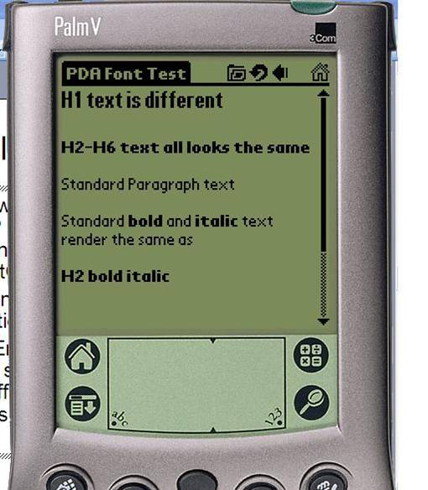  Figure 10 – Palm OS Emulator | Within the Palm OS development community there is an emulator that has been developed. It’s quite a sophisticated tool, allowing you to load in different ROM images for the different devices and different OS levels. Additionally, there are different skins available to make the emulation look like the PDA in question. The image at right is a screen shot of the emulator in Palm V with OS4.1.  While there many debugging tools and capabilities available, where the Palm OS Emulator (POSE) was most valuable to me was in its ability to do screen captures. All of the screen shots in this report and in my presentations were generated using the POSE in a Palm IIIc OS3.5.2 mode.

Without this tool, I would have had to take screen shots using a standard browser, and this would not have been representative of what the application was going to look like.

5.2 Graphics Slicing and Creating Maps

Another challenge was creating the graphics for the different graphics directories. I did not have a strong background in working with graphics, and this was originally a daunting task. Through various Internet searches, I discovered that splitting up a larger graphic into a series of smaller ones is referred to as ‘slicing’ and that the Fireworks application by Macromedia was particularly well suited to this function.

After spending some time learning the Fireworks interface, it wasn’t long before I discovered how easy it was to use this tool not only to create the slices I wanted, but also to create the different images at different sizes and resolutions. The only problem that remained was iterating through a series of scanned DPI settings until I found images that reduced legibly when reduced to the 60 x 60 pixel size needed by the smallest resolution PDA devices.

This was another instance where previewing the images on a PC browser was misleading. The PC screen is so much higher a resolution that it distorts how small images will render when on a PDA. The POSE was again useful in this regard, and more faithfully reproduced how a graphic would display. But even the POSE was misleading because the size of the PDA in the emulator is at least twice as large as a PDA in real life. So the only real proof about how a graphic would display is to download the image to an actual PDA.

5.3 Database evolution

Once the decision to create a database was made, it took a few iterations for the design to evolve from perceived relationships between objects to an initial database design. It wasn’t until I started to populate the tables with information and display the information in sample display pages that I started to notice that I wasn’t distinguishing between service data elements to the level of granularity that I needed to. This was mostly because I realized I had not properly evaluated the nature of services – that not only can services have single instance on multiple maps (such as dining), but that it can also have multiple instances on a single map. The only way I can describe this is a many-to-many-to-many relationship between service types, services instances and maps.

This led to the expansion of the SERVICE_LOCATION_TAB to include a unique label for describing each unique instance of a service, LOCATION_NAME.

6. Results

The UAA Self-Guided Campus Tour was completed on time and satisfies all the initial requirements. While there is still the need for a GUI front end to the database to manage data entry – especially in regards to the several join tables - the requirement has been met that content be easily updated and appended. The application exceeds expectations on this account because adding new records to the database results in new content be automatically generated the next time content is requested. For the most part, the database will ever be the only part of the application that will be updated on a regular basis.

6.1 Final Program

Several screenshots of the final program are shown below. There are well over 300 different pages in the complete application, many of them interconnected in multiple ways. What is shown below are representative samples of the types of pages a user might see if they arrived on Campus and parked in the West Parking Lot. The dialogs below the images describe what steps the user is going through and how they relate to taking a tour.

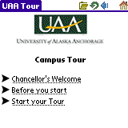 | 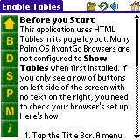 | 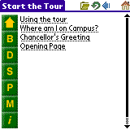
1 | 2 | 3
The user begins his tour at this screen, and taps ‘Before you start’ to see what’s there. | The user reads about how to properly configure their PDA browser so they can best enjoy the Tour. | The user taps on the ‘Home’ icon and is returned to the start menu. Curious to know who the chancellor is, he taps on the ‘Chancellor’s Greeting’ link.

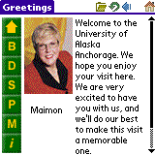 | 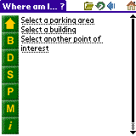 | 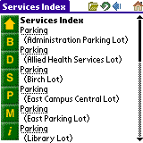
4 | 5 | 6
A greeting from incoming Chancellor Maimon welcomes him. He reads it and goes back to the home page by clicking the ‘Back’ browser icon. He then taps the ‘Where am I on Campus?’ link. | The user has a choice of three options to help him find out where he is on campus. Knowing which parking lot he’s in, he taps on the link to ‘Select a parking area’ | A list of parking lots is presented to him. He scrolls down until he finds the entry for ‘West Parking Lot’, and taps it.

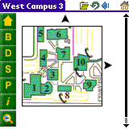 | 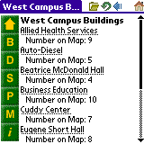 | 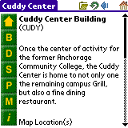
7 | 8 | 9
A map is displayed showing all the buildings in his immediate area. He taps the ‘B’ button to display a list of all buildings he sees on the map, since he wants to know what building 7 is. | Looking through the list of buildings and finds that the Cuddy Center is Building 7 on the previous map. He taps the ‘Cuddy Center’ link to find out more about the building. | A page with details about the Cuddy Center is displayed. He reads that the Floral Design department is located in the building. He taps on the link to find out more details about Floral Design…

… and so it goes for our intrepid visitor. He learns and discovers what interests him, and he’s free to explore in whichever direction he wishes at a pace that’s comfortable for him.

6.2 Future Steps

Time did not allow me to construct one final management piece of the application’s total package – a data entry GUI front end for the database. This final piece would simplify the content management piece of the application.

Additionally, I believe that the maps graphics, especially for those smaller resolution PDA devices could use the help of a more competent graphic artist. The menu buttons could also have the letters replaced with images, although this is minor.

One of my testers commented that it would be nice if some of the buildings or points of interest could have pictures. While this wasn’t considered for the initial prototype, the current architecture of the application would certainly allow for expanding the application to include this request. The only effect that would need to be considered would be the overall footprint of the application on the PDA, and how much it would grow if many graphics were added.

7. Summary and Conclusions

This application has a complexity that belies the simplicity of its presentation. While the graphic layout and data presentation seem like could have been produced by anyone who picked up an HTML ‘How-To’ book, there is a level of complexity and sophistication behind the application.

The underlying database shows not only an understanding data normalization, but also shows an ability to translate complex relationships into simple structures. The same can be said for the simple elegance of the ColdFusion pages built to interface with the database and then generate and render the HTML. These pages showed the ability to deconstruct a problem into constituent parts, and then re-combine them into a powerful yet easy to maintain solution.

I believe the UAA Campus Self-Guided Tour meets its prototype goals successfully. While not completely polished around all the edges, it demonstrates that an application can be constructed to generate and display a wide variety of related information in an easy to maintain database and simply constructed application logic. It leverages existing delivery technologies to solve the problem of distributing the application to multiple hardware platforms.

The most difficult challenges during the course of completing this project were related to dealing with the small display areas presented by some of the PDA devices, especially with regards to the maps areas While I believe I have done an adequate job with the existing graphics images, I believe that in the hands of a more skilled graphic artist that better maps could be obtained.

I am very proud of the work that I have done throughout the course of this project. I think that I have adequately demonstrated a wide range of Computer Science related skills. I have demonstrated an understanding of database design, the ability to construct efficient algorithms, and the ability to perform complex problem analysis. I have learned to gather requirements; investigate, evaluate and propose several possible solutions, and execute a chosen solution with efficient use of code.

I want to thank all of those at UAA that have helped me reach the end of a very long road. It took me three different tries over the course of the last 6 years to finally complete this course and complete my degree. My most sincere thanks go to Dr. Hilary Davies, Dr. Kirk Scott and Dr. Kenrick Mock. Without the cooperation, encouragement and guidance of these three individuals, I could never have achieved the level of success that I have, both with this application and in my chosen career in Computer Science.

8. References

iAnywhere Solutions, Inc. 2003. AvantGo Channel Developer Guide. http://www.ianywhere.com/avantgo/developer/channel_developer/index.html

iAnywhere Solutions, Inc. 2003. AvantGo HTML Style Guide. http://www.avantgo.com/doc/developer/styleguide/styleguide.html

iAnywhere Solutions, Inc. 2003. AvantGo Palm Guide. http://www.avantgo.com/doc/mobile/palm/index.html

Kacin, Marty. 1999. Optimizing Web pages for handheld devices. http://www.palmpower.com/issues/issue199902/avantgotips001.html

Neilsen, Randy and Lichtin, Hal. 2003. CFML Reference Guide, editors Linda Adler and Noreen Maher. San Francisco: Macromedia, Inc.

Stowell, Carter. 1999. Designing Web Sites for PDAs. http://hotwired.lycos.com/webmonkey/99/20/index2a.html?tw=design

Appendix A: User Manual

UAA Self-Guided Campus Tour User’s Guide
April 2004

Introduction

The UAA Self-Guided Campus Tour is an application that runs on your Personal Digital Assistant (PDA) that lets you explore the UAA campus from your own perspective at your own pace. You choose where you start, where you go, and what you do. The major categories of information (Buildings, Departments, Services, Points of Interest and Maps) are all inter-connected to let you explore in whichever way suits you.

This User’s Manual is designed to give you an overview of the application and to familiarize you with its controls. This allows you to focus more on what you want to explore rather than on how to find the information.

Getting the Tour onto your PDA

There are a lot of different PDAs in the world. We designed the application work on a wide variety of them. The tour uses a PDA web-browser application called AvantGo, which is available at http://www.avantgo.com. It is available for a large number of PDAs, listed below in Table 1.

Operating System | Devices Include
Palm OS | Palm Zire, m100, m500 series; Handspring Treo; Sony CLIÉ NR, T, SJ series
Palm OS 5 | Palm Tungsten T/T2/T3/C/E, Palm Zire 71, Handspring Treo 600, Sony NX, NZ and UX
Pocket PC | Compaq/HP iPAQ; HP Jornada 540, 560 series; Toshiba e310, e330, e740
Windows CE | Casio E10, E100; HP Jornada 420, 680; Philips Nino 500
Symbian 60 | Nokia 3650, 7650
RIM Blackberry | RIM 857 and 957 Blackberry handhelds

Table 1 – Supported PDAs

The first step is to set up an AvantGo account (it’s free) and downloading a browser onto your PDA. The second step is to subscribe to the ‘UAA Self-Guided Campus Tour’ by using the following link: UAA Self-Guided Campus Tour. The Tour will download to your PDA the next time you sync your PDA.

Start the AvantGo browser on your PDA. The opening page will list all the channels you’ve subscribed to. Tap on the link for ‘UAA Self-Guided Campus Tour, and you’re ready to begin.

Pre-Tour Task: Configure the Browser

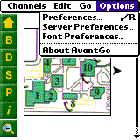  Figure 1  Setting Browser Preferences  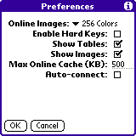  Figure 2  Preferences | A good experience with the Tour begins by making sure the AvantGo browser is properly configured. Open the menus for the AvantGo application (each device is a little different in this regard), and select ‘Options’ and then ‘Preferences’, as illustrated in Figure 1.  Select the following preference options as in Figure 2:  Show Tables  Show Images  Set the Max Online Cache (KB) value based on your PDA’s screen size and color resolution. Use the following rules as a guideline:
   | 160x160 | 320x240 | 320x320
  Color | 200 KB | 640 KB | 640 KB
  Monochrome | 200 KB | 400 KB | 400 KB

Starting the Tour

Figure 2  Opening Page  Figure 4  Start the Tour  Figure 5  Where am I...? | Now that we have all the preliminary tasks out of the way, let’s start the tour! Figure 3 shows the screen you’ll see when you first start the tour. The three links greet you with a welcoming message from UAA Chancellor Dr. Elaine Maimon, a link to start the tour, and a link to help documents.  To start the tour, tap the ‘Start your Tour’ link.  Figure 4 introduces you to both the start menu and the navigational controls used throughout the application. The two primary links of interest on this page are:  Using the tour – provides an overview of the navigational controls.  Where am I on Campus? - gives you a number of ways to orient yourself to where you are on campus. (Figure 5)  - A parking lot  - A building you can identify  - Another interesting object, like a statue or a bridge  If you know where you want to start, use the buttons on the left edge of the page to head off on your own. Tapping a button will display the following:
   | Home. Brings you back to the Start Page (Figure 4).
   | Buildings. Displays a list of buildings. When viewing maps, tapping this button displays a list of buildings on that map.
   | Departments. Displays a list of departments. Like the Buildings button, tapping this button while viewing a map displays a list of departments in the buildings on that map.
   | Services. Displays a list of services, like Enrollment or Parking Services, as well as information about services like the Campus Shuttle or Emergency Phones.
   | Points of Interest. Displays a list of things you may find of interest. Sometimes these things are in buildings, and sometimes outside. As with the other buttons, if you’re viewing maps, this button will list points of interest for that map.
   | Maps. The main UAA Campus has been split up into a grid of maps so they can be more easily viewed on your PDA. You can use these to explore the layout of the campus, or to find out what’s going on in a particular area of campus, or just see how to get from point A to point B.  There are maps for four areas of campus – East, West, Housing, and Off-Campus. We’ll discuss maps in more detail in the next section.
   | Information and help. Displays links to general campus information as well as interesting anecdotes about UAA and its history.
   | Zoom Out. You’ll see this button when viewing some maps. Its use will be explained next.

Using the Maps

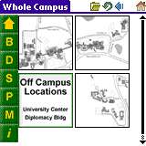  Figure 6  Whole Campus Maps  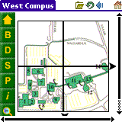  Figure 7  Medium Detail  Figure 8  Most Detail  Figure 9  Building Details  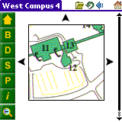  Figure 10  Maps to the North, West and East (but not South) | The maps provide an interesting way to explore the campus. They allow you to explore the campus at different levels of detail, and provide you with information relevant to the level you’re viewing.  Maps are viewed by tapping the button.  The broadest, or ‘Whole Campus’ view of the campus is viewed when first tapping the Maps button, as shown in Figure 6. Tapping the button for Buildings, Departments, Services, etc. will display results for the whole campus.  More Detail  A grid of maps means that there is more detail available. Tapping on the map of interest will display the new level of detail. For example, if you tap the image in the upper left of the ‘Whole Campus’ view, a detail map of the ‘West Campus’ will display, as shown in Figure 7.  In a likewise manner, clicking on the map in the lower left of the West Campus maps displays the most detailed map of this area of campus, as shown in Figure 8.  You’ll notice two things that have changed about the navigation buttons. First, the button for the maps is gone, and the Information button has slid up one spot. At the bottom of the stack of buttons is now the ‘Zoom Out’ button. Its purpose is to allow you to move up to a less detailed set of maps.  For example, tapping on the ‘Zoom Out’ button when viewing the Figure 8 map displays the Figure 7 maps. Clicking on the Figure 7 maps takes you to the Figure 6 map set.  As mentioned before, the information presented when viewing maps is relevant to the map currently displayed. When viewing the map in Figure 7. If you tap the ‘Buildings’ button, the list that’s displayed contains the list of buildings on this map as show in Figure 9.  You’ll notice that the button bar has now changed back to its prior layout – but there’s something different about how it works. Since you’ve accessed this list by viewing a map, the buttons ‘remember’ this, and take on an added convenience.  For example, if you tap the ‘Departments’ button in Figure 9, you’ll see a list of Departments in the list of buildings you’re viewing. After viewing the Departments, tapping ‘Services’ displays the list of services ON THE SAME MAP. Additionally, tapping the ‘Maps’ button redisplays the last map you viewing.  Navigating the Maps  You may have noticed in Figures 7 and 8 that there were little directional arrows around the maps that look like this: . These icons indicate there are more maps, at the same level of detail available by tapping on the arrow.  The direction of the area is roughly equivalent to moving to a map that’s North, South, East or West of the map you’re on for ‘Up’, ‘Down’, ‘Right’ or ‘Left’ respectively. If there is no arrow on a particular side of a map, there isn’t an adjoining map on that side, as illustrated in Figure 10.

Viewing the Details

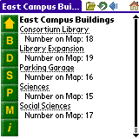  Figure 11  Another Building Summary  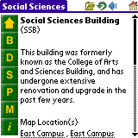  Figure 12  SSB Building Details (1)  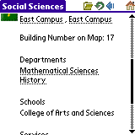  Figure 13  SSB Building Details (2)  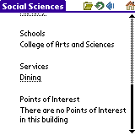  Figure 14  SSB Building Details (3) | As we previously illustrated, the lists that are generated when looking at particular maps relates to the buildings displayed on that map. This is referred to as a summary map. Let’s look briefly at the Building Summary list shown in Figure 11.  You’ll notice the page heading indicates which part of campus the list is relevant for. In this case, it’s East Campus. Listed below this are links to further details about particular buildings, such as the Social Sciences building. Below each link is a number which indicates which building number on the map this entry corresponds with. This means that the Map’s building number 17 is the Social Sciences Building.  Suppose that you want to know more about the Social Sciences building? Tap on the Social Sciences link to display detailed information about the building. The application displays Figure 12.  Below the name of the building at the top will be a building description. Below this information is a list of Map Locations the building appears on. Since map boundaries sometimes dissect a building, it is possible that different portions of the same building will be displayed on different maps. Tapping on the map name displays the highest detail map  As you scroll down to view the rest of the entry (Figures 13 and 14), you see that there is information relative to the Departments, Services, and Points of Interest in the building.  In Figure 13, you see references to the Mathematical Sciences and the History Department. These are links to detailed information about these departments. Tap them to view the information

In Closing…

When viewing the building detail information as a whole, you see that all of the major categories of information that the tour provides (Buildings, Departments, Services, Points of Interest and Maps) are represented. This is true throughout the application for any detail display. Each detailed piece of information is linked to other detailed pieces of information. In this way, you’re free to explore the UAA Campus however you like.

Enjoy!

Appendix B: Code Listings

This section contains the full code for the following pages:

agHTTPHeaders.cfm
menubar.cfm
services_data.cfm
services_data_detail.cfm
services_summary.cfm
services_detail.cfm
map1x.cfm
map111.cfm

agHTTPHeaders.cfm

<!-- agHTTPHeaders.cfm v1.0 -->

<!---
This CustomTag processes the HTTP Header information present in each AvantGo server request.
These values give information about OS, OS Version, color depth and resolution. We use this information to determine which graphics library and page templates to choose when rendering each page.

For the first Self Guided Tour version, we're interested in four values.
The two of most importance are ScreenSize and Color-Depth.

X-AvantGo-ScreenSize: This is the maximum pixel height and width we can use for images and text
layout. For higher resolution screens, we may wish to present different images and different
table layouts.
X-AvantGo-ColorDepth:
The values indicate the number of bits of different colors or shades of gray that can be rendered.
2: 4 bit grey scale
4: 16 bit grey scale
8: 256 bit color
16: 65,536 colors

X-AvantGo-DeviceOS:
The OS of the Device requesting the Data (Palm OS, WinCE, Symbian, etc.)
X-AvantGo-DeviceOSVersion:
The OS version. Different OS versions may have different rendering
capabilities that we may wish to take advantage of. For example, the AvantGo Browser for
Palm OS Version 5 supports a broader range of HTML and Javascript functions than 4.0 and prior.

While the Header names are plain text, the actual values are Base64 encrypted by the AvantGo Server. To get a useful value, these values must be decrypted. To decrypt the encoded string, we must first convert the value to binary, and convert that value back to a string.

The header information is read into a key=value data structure by using the GetHttpRequestData() function. When the structure is queried with the key, the value returned is decrypted and stored in a local variable. The combination of local variables are then processed to determine which graphics gallery to use.

Extract and save as local variables:
ColorDepth
DeviceOSVersion
DeviceOS
UserID
ScreenSize
DeviceID

We will use a ColdFusion Server Mapping for '#request.avantgo_home#/' to always find the
img directory, regardless of how deep we are in the application
--->

<cfset x = GetHttpRequestData()>

<cfscript>
avantGoParams = "X-AvantGo-DeviceOSVersion,X-AvantGo-DeviceOS,X-AvantGo-UserID,X-AvantGo-ScreenSize,X-AvantGo-ColorDepth,X-AvantGo-DeviceID";
</cfscript>

<cfloop collection="#x.headers#" item="http_item">

<cfif ListFindNoCase(avantGoParams, http_item) gt 0>
<cfset shortName = right(http_item, find("-", reverse(http_item)) - 1)>
<cfset temp = SetVariable("Variables."&#shortName#, ToString(toBinary(StructFind(x.headers,
http_item))))>
</cfif>

</cfloop>

<cfparam name="Variables.ColorDepth" default="16">
<cfparam name="Variables.ScreenSize" default="320X320">
<cfparam name="Variables.DeviceOS" default="PALM_OS">

<!--- Convert ScreenSize and ColorDepth to graphics directories --->
<cfswitch expression="#Variables.ColorDepth#">
<cfcase value="4">
<cfset variables.graphics_dir = "#request.avantgo_home#/img/4bit">
<!--- ScreenSize assumed 150x150 --->
</cfcase>
<cfcase value="8">
<cfset variables.graphics_dir = "#request.avantgo_home#/img/8bit">
<!--- Screen size assumed 150x150 --->
</cfcase>
<cfcase value="16">
<cfif Variables.ScreenSize EQ "320x320">
<cfset variables.graphics_dir = "#request.avantgo_home#/img/16bit/320">
<cfelse>
<!--- ScreenSize assumed "240x320" for PocketPC--->
<cfset variables.graphics_dir = "#request.avantgo_home#/img/16bit/240">
</cfif>
</cfcase>
<cfdefaultcase>
<!--- default to 4 bit grey scale (16 shades) --->
<cfset variables.graphics_dir = "#request.avantgo_home#/img/4bit">
</cfdefaultcase>
</cfswitch>

menubar.cfm

<!-- menubar.cfm v1.0 -->
<!---

Name: menubar_data.cfm
Version: 1.0
Purpose: I see if we're in the maps area, and modify the links to other information, to
make them more contextual. If we're loading a map-related detail page, maintain the
mapNumber value.

Input parameters:
-> [url.mapNumber] optional

Dataset
None

Created by: Edward Wickham
Email: ewickham@gci.net
Create date: 2004/04/08

Last Edited by:
Email:
Last Edit date:

Version notes:

--->

<cfsetting enablecfoutputonly="yes">
<cfset showMapButton = "Y">

<cfif isDefined("url.mapNumber")>
<cfset mapNumber = #url.mapNumber#>
<cfelseif REFind("\/maps\/",cgi.SCRIPT_NAME) GT 0>

<cfscript>
thisFile = getFileFromPath(cgi.script_NAME);
mapGrid = listGetAt(thisFile,1,".");
mapNumber= right(mapGrid,len(mapGrid)-3);
if (mapNumber GT 1)
showMapButton = "N";
</cfscript>

<cfelse>
<cfscript>
mapNumber = "1";
</cfscript>
</cfif>

<cfsetting enablecfoutputonly="no">

<cfoutput>
<a href="#request.avantgo_home#/start.cfm">
<img src="#variables.graphics_dir#/home_button.gif"></a><br>
<a href="#request.avantgo_home#/buildings/buildings_summary.cfm?mapNumber=#mapNumber#">
<img src="#variables.graphics_dir#/building_button.gif"></a><br>
<a href="#request.avantgo_home#/departments/departments_summary.cfm?mapNumber=#mapNumber#">
<img src="#variables.graphics_dir#/department_button.gif"></a><br>
<a href="#request.avantgo_home#/services/services_summary.cfm?mapNumber=#mapNumber#">
<img src="#variables.graphics_dir#/services_button.gif"></a><br>
<a href="#request.avantgo_home#/points/poi_summary.cfm?mapNumber=#mapNumber#">
<img src="#variables.graphics_dir#/poi_button.gif"></a><br>

<cfif showMapButton EQ "Y">
<a href="#request.avantgo_home#/maps/map#mapNumber#.cfm">
<img src="#variables.graphics_dir#/map_button.gif"></a><br>
</cfif>

<a href="#request.avantgo_home#/help/help1.cfm">
<img src="#variables.graphics_dir#/info_button.gif"></a><br>
</cfoutput>

services_data.cfm

<!--- services_data.cfm v1.0 --->

<!---

Name: services_data.cfm
Version: 1.0
Purpose: I query the database for all services summary pages. I use up to two different
URL variables to modify how I extract information from the database. If I receive the URL
variable mapNumber, I get a list of all the services on a particular map. If I receive the
URL variable srv, I get a list of all services of that type, regardless of which map they
are on. If I receive no URL variables, I return all services on all maps.

Input parameters:
-> [URL.mapNumber] optional
-> [URL.srv] optional

Dataset
getServices

Created by: Edward Wickham
Email: ewickham@gci.net
Create date: 2004/04/10

Last Edited by:
Email:
Last Edit date

Version notes:

--->

<cfif isDefined ("URL.mapNumber") and URL.mapNumber GT "1">

<cfif findnocase('x',URL.mapNumber) gt 0>
<cfset searchField = "summary_map_id">
<cfelse>
<cfset searchField = "map_id">
</cfif>

<cfquery name="getMaps" datasource="uaa_sgt">
select description
from map_tab
where #searchField# = <cfqueryparam value="#URL.mapNumber#" cfsqltype="cf_sql_varchar">
</cfquery>

<!--- Get service information specific to this map --->
<cfquery name="getServices" datasource="uaa_sgt">
select distinct a.name, b.service_location_id, b.location_name as location, b.map_id
from services_tab a, service_location_tab b, map_tab c
where a.service_abbr = b.service_abbr
and b.map_id = c.map_id
and c.#searchField# = <cfqueryparam value="#URL.mapNumber#" cfsqltype="cf_sql_varchar">
order by name
</cfquery>

<cfelseif isDefined("URL.srv")>

<!--- Get information about this service on all maps --->
<cfquery name="getServices" datasource="uaa_sgt" >
select a.name, b.map_id, b.service_location_id, b.location_name as location
from services_tab a, service_location_tab b
where a.service_abbr = b.service_abbr
and a.service_abbr = <cfqueryparam value="#URL.srv#" cfsqltype="cf_sql_varchar">
order by name, location_name
</cfquery>

<cfelse>

<!--- Get information about all services --->
<cfquery name="getServices" datasource="uaa_sgt" >
select distinct name, lcase(a.service_abbr) as abbr
from services_tab a
order by name
</cfquery>

</cfif>

services_detail_data.cfm

<!-- services_detail_data.cfm v1.0 -->

<!---
Name: services_detail_data.cfm
Version: 1.0
Purpose: I query the database for details related to a chosen service category.

Input parameters:
-> URL.svc_id

Dataset
getServicesDetails

Created by: Edward Wickham
Email: ewickham@gci.net
Create date: 2004/04/10

Last Edited by:
Email:
Last Edit date

Version notes:

--->

<cfif isDefined("URL.svc_id")>

<cfset thisSvc = URL.svc_id>

<cfquery name="getServicesDetail" datasource="uaa_sgt">
select a.name, a.description, d.name as building, b.map_id, b.location_name,
d.building_abbr, c.description as location
from map_tab as c
inner join (building_tab as d
right join (services_tab as a
inner join service_location_tab as b
on a.service_abbr = b.service_abbr)
on d.building_abbr = b.building_abbr)
on c.map_id = b.map_id
where b.service_location_id= <cfqueryparam value="#thisSvc#" cfsqltype="cf_sql_varchar">
</cfquery>

</cfif>

services_summary.cfm

<!-- services_summary.cfm v1.0 -->

<!---
Name: services_summary.cfm
Version: 1.0
Purpose: I format the output of any request for a summary of services, whether the reference
is to a particular map, a particular service or all available services. Where appropriate
I dynamically construct URL links to relevant pages.

Input parameters:
-> [URL.mapNumber] optional
-> [URL.svc] optional

Included pages:
services_data.cfm
menubar.cfm

Datasets
[getMaps] optional - built by services_data include
getServices - built by services_data include

Created by: Edward Wickham
Email: ewickham@gci.net
Create date: 2004/04/08

Last Edited by:
Email:
Last Edit date:

Version notes:
--->

<cfinclude template="services_data.cfm">

<cfif isDefined("getMaps.description")>
<cfset pageName = '#getMaps.description# Services'>
<cfelse>
<cfset pageName = "Services Index">
</cfif>

<html>

<head>
<cfoutput><title>#pageName#</title></cfoutput>
<meta http-equiv="HandheldFriendly" content="True">
</head>

<body>

<table border="0" cellpadding="1" cellpadding="1">
<tr>
<td valign="top">
<cfinclude template="/avantgo_home/menubar.cfm">
</td>
<td valign="top">
<b><cfoutput>#pageName#</cfoutput></b><br>
<cfif getServices.recordcount gt 0>

<cfoutput query="getServices">

<!--- Since Services are also used by the locater.cfm page ,
modify the link href to point to the map if we're here from the locater,
othewise point to the point of interest detail page --->

<cfif isDefined("url.locater")>
<cfset link_url = "../maps/map#trim(map_id)#.cfm">
<cfelseif isDefined("getServices.service_location_id")>
<cfset link_url = "services_detail.cfm?svc_id=#service_location_id#">
<cfelse>
<cfset link_url = "services_summary.cfm?srv=#abbr#">
</cfif>

<!--- High level summary shows service categories --->
<a href="#link_url#">#name#</a>
<cfif isDefined("location") AND location gt "">
<br>&nbsp;&nbsp;(#location#)
</cfif><br>

</cfoutput>
<cfelse>
No services are on this map.
</cfif>
</td>
</tr>
</table>
</body>
</html>
services_detail.cfm

<!-- services_detail.cfm v1.0 -->
<!---
Name: services_detail.cfm
Version: 1.0
Purpose: Using data created in services_detail_data, I format the output

Input parameters:
<-> thisService

-> Datasets
getDeptDetails
getMaps

Created by: Edward Wickham
Email: ewickham@gci.net
Create date: 2004/04/08

Last Edited by:
Email:
Last Edit date

Version notes:

--->

<cfinclude template="services_detail_data.cfm">
<html>
<head>
<meta http-equiv="HandheldFriendly" content="True">
<cfoutput><title>#getServicesDetail.name#</title></cfoutput>
</head>

<body>
<table border="0" cellpadding="1" cellpadding="1">
<tr>
<td valign="top">
<cfinclude template="/avantgo_home/menubar.cfm">
</td>
<td valign="top">
<table border="0" cellpadding="1">
<cfoutput query="getServicesDetail">
<tr>
<td>
<b>#name# Service</b>
<cfif location_name gt "">
<br>(#location_name#)
</cfif>
</td>
</tr>
<tr><td>&nbsp;</td></tr>
<tr>
<td>Map <a href="../maps/map#map_id#.cfm"> #location#</a></td>
</tr>
<tr><td>&nbsp;</td></tr>

<cfif #description# gt "">
<tr><td>#description#</td></tr>
<tr><td>&nbsp;</td></tr>
</cfif>

<cfif #building# gt "">
<tr><td valign="top">Building</td></tr>
<tr>
<td valign="top" align="left">
<a href="../buildings/building_detail.cfm?bldg=#building_abbr#">
#building#
</a>
</td>
</tr>
</cfif>
</cfoutput>
</table>
</td>
</tr>
</table>
</body>
</html>

map1x.cfm

<!--map1x.cfm v1.0 -->

<!---

Name: map1x.cfm
Version: 1.0
Purpose: I present a grid layout for the second detail level of maps referenced in map1.
I provide a navigational link to other second level detail maps to the right and below.
I also add a new 'Zoom Out' button at the bottom after the normal menu buttons.

Input parameters:
-> request.avantgo_home
-> variables.graphics_dir

Dataset:
None

Templates included:
menubar.cfm

Created by: Edward Wickham
Email: ewickham@gci.net
Create date: 2004/04/08

Last Edited by:
Email:
Last Edit date:

Version notes:

--->
<html>
<head>
<title>West Campus</title>
<meta http-equiv="HandheldFriendly" content="True">
</head>
<body>
<table border="0" cellpadding="0" cellpadding="0">
<tr>
<td valign="top">
<cfinclude template = "/avantgo_home/menubar.cfm">
<cfoutput>
<a href="#request.avantgo_home#/maps/map1.cfm">
<img src="#variables.graphics_dir#/zoom_out_button.gif"></a>
</cfoutput>
</td>
<td valign="top">
<cfoutput>
<table border="0" cellpadding="0" cellspacing="0" align="center">
<tr><td colspan="3" align="center">&nbsp;</td></tr>
<tr>
<td valign="middle">&nbsp;</td>
<td>
<table border="0" cellpadding="0" cellspacing="0" align="center">
<tr>
<td>
<a href="#request.avantgo_home#/maps/map111.cfm">
<img src="#variables.graphics_dir#/map11.gif"></a>
</td>
<td>
<a href="#request.avantgo_home#/maps/map121.cfm">
<img src="#variables.graphics_dir#/map12.gif"></a>
</td>
</tr>
<tr>
<td>
<a href="#request.avantgo_home#/maps/map131.cfm">
<img src="#variables.graphics_dir#/map13.gif"></a>
</td>
<td>
<a href="#request.avantgo_home#/maps/map141.cfm">
<img src="#variables.graphics_dir#/map14.gif"></a>
</td>
</tr>
</table>
</td>
<td valign="middle">
<a href="map2x.cfm"><img src="#variables.graphics_dir#/rt_arrow.gif"></a>
</td>
</tr>
<tr>
<td colspan="3" align="center">
<a href="map3x.cfm"><img src="#variables.graphics_dir#/dn_arrow.gif"></a>
</td>
</tr>
</table>
</cfoutput>
</td>
</tr>
</table>
</body>
</html>

map111.cfm

<!--maps111.cfm v1.0 -->

<!---

Name: maps111.cfm
Version: 1.0
Purpose: I display the most detailed map. I provide links to adjoining maps (logically) to
the east and south. I add a 'Zoom Out' button below those in the standard menubar.

Input parameters:
-> request.avantgo_home
-> variables.graphics_dir

Dataset

Created by: Edward Wickham
Email: ewickham@gci.net
Create date: 2004/04/08

Last Edited by:
Email:
Last Edit date:

Version notes:

--->
<html>
<head>
<title>West Campus 1</title>
<meta http-equiv="HandheldFriendly" content="True">
</head>
<body>
<table border="0" cellpadding="0" cellpadding="0">
<tr>
<td valign="top">
<cfinclude template = "/avantgo_home/menubar.cfm">
<cfoutput>
<a href="#request.avantgo_home#/maps/map1x.cfm">
<img src="#variables.graphics_dir#/zoom_out_button.gif"></a>
</cfoutput>
</td>
<td valign="top">
<cfoutput>
<table border="0" cellpadding="1" cellspacing="0" align="center">
<tr>
<td colspan="3" align="center">&nbsp;</td>
</tr>
<tr>
<td>&nbsp;</td>
<td><img src="#variables.graphics_dir#/map111.gif"></td>
<td>
<a href="#request.avantgo_home#/maps/map121.cfm">
<img src="#variables.graphics_dir#/rt_arrow.gif"></a>
</td>
</tr>
<tr>
<td colspan="3" align="center">
<a href="#request.avantgo_home#/maps/map141.cfm">
<img src="#variables.graphics_dir#/dn_arrow.gif"></a>
</td>
</tr>
</table>
</cfoutput>
</td>
</tr>
</table>
</body>
</html>

Appendix C: Database Schema

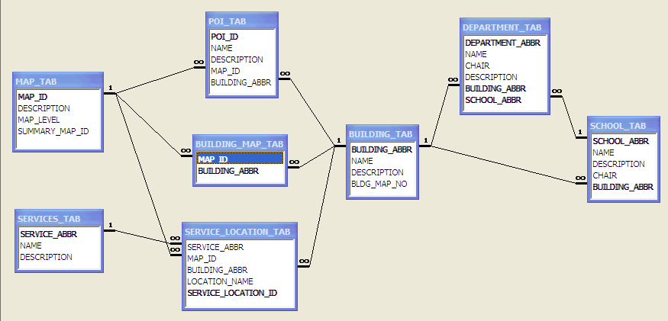

David Coursey, Is Palm better than Pocket PC?, February 14, 2003, http://asia.cnet.com/newstech/perspectives/0,39001148,39114252,00.htm
Robyn Greenspan, Colorful Growth of PDAs, October 22, 2002, http://cyberatlas.internet.com/big_picture/hardware/article/0,1323,5921_1485831,00.html
Author not indicated, What Factors Will Push PDAs into the Mainstream, November 1, 2002, http://mobileadvisor.com/doc/11372

