1. Company Overview

GCI was founded in 1979 as a long distance telecommunications provider, and processed its first long distance call on Thanksgiving Day 1982. In 1991, GCI leased capacity on the North Pacific Cable, the only fiber optic cable between Alaska and the lower forty-eight states. Shortly thereafter, GCI began securing Network Management contracts for clients such as BP, NBA, and First National Bank of Alaska. In 1995, GCI launched a statewide satellite network that would eventually provide long distance phone service, Internet, and Tele-Health services to over one hundred communities in rural Alaska.

GCI expanded services just one year later to include cable television. 1996 was also the year GCI began building an extensive Metropolitan Area Network to provide high-speed data connectivity in Anchorage, Fairbanks, and Juneau. 1997 was a milestone year, as GCI became the state’s first company to make the Standard and Poor’s Small Cap 600 Index, and also began offering residential phone service.

The next two years saw the construction of GCI’s own submarine fiber optic connectivity to the lower forty-eight states and the introduction of cable modem Internet access. By 2000 GCI had become the state’s largest Internet provider and had also secured a thirty percent market share in residential phone service. One year later GCI purchased the eight hundred mile long fiber optic system on the Trans Alaska pipeline, and expanded satellite services to include schools in the lower forty-eight states.

Currently GCI enjoys a forty percent market share in residential phone service and has just launched Voice Over IP as the primary platform for residential telephone service.

2. Project Overview

GCI provides local and long distance telephone service via Lucent 5ESS telephony switches. There are five switches in the GCI network, one each in Seattle, Fairbanks, Juneau, and two in Anchorage. These switches output multiple constant streams of data on traffic statistics, equipment diagnostics, and call processing. Several departments in GCI use this data. For example traffic engineers consult the traffic statistics, switch technicians consult the diagnostic data, and surveillance technicians monitor the call processing.

The subject of my internship was the Traffic 30 reports, which the switches output once an hour, twenty-four hours a day. A Traffic 30 report is a collection of up to twenty-five section reports, each one documenting the hourly statistics of a specific functionality in the switch.

The Operations System Support Department in the Network Support Group is responsible for collecting and storing this data. Preceding the completion of my internship, the data was output from the Lucent 5ESS switch to a terminal server, then to a Solaris server, where a script wrote the bulk file to a backup disk. From there a Korn Shell script output the back up file to server OPS A where it was archived. The Korn Shell script also output the bulk file to server OPS B, where the individual section reports were parsed out. From there each section report was sent to yet another server, OPS C, where Visual Basic parsed out the data for each insert statement. Finally the insert statements were sent to the SQL server on OPS D, where anyone on the GCI intranet would have access to the data.

Figure 1: Previous Design
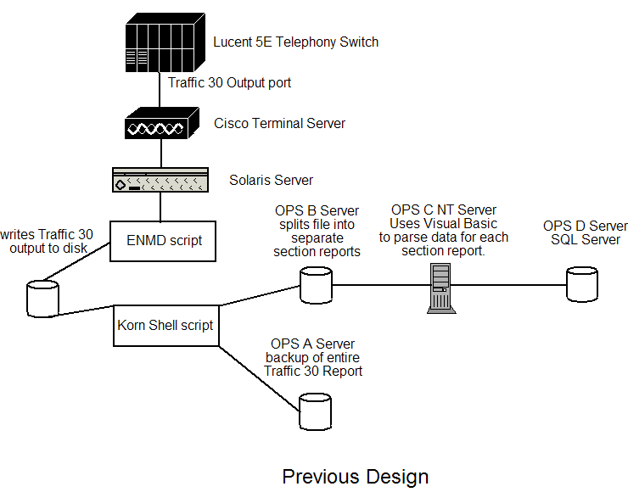

This system was difficult to maintain and prone to a variety of problems. There were multiple points of failure, and backtracking to find the source of a failure was time intensive. Also the process of collecting, parsing, and transferring the reports was slow, taking nearly an hour to complete.

The Operating Systems Support Department began experimenting with Perl to process the 5ESS data streams. Using a combination of Perl’s pattern matching and IO::Socket package, they collected the call processing data stream into a file. The supervisor of OSS, Doug Huvar, wanted to apply this to the Traffic 30 reports and also take it a step further to parse each section report dynamically, then write each section report to the public database. This was the goal of my internship.

3. Planning

Doug and I agreed I should have a working knowledge of the existing system for processing the reports. This would help me clarify which processes I would need to carry over into the Perl script. In January I began reviewing the network drawings and Korn Shell scripts for the Traffic 30 reports. Focusing on reusability, I noted the existing processes for parsing the reports. Some of those processes I eventually did translate directly to Perl.

Doug showed me a couple of Perl scripts with sections of code he thought would be useful for the Traffic 30 reports. One established a socket connection and read in one byte at a time concatenating each byte until an end of line character was reached, then wrote the line to a file. The other used Perl’s pattern matching to identify parameters in a line input from a configuration file. Each script also contained error checking and debugging information OSS wanted to maintain in the new design. I studied these scripts and developed ideas on how to apply those functionalities to the Traffic 30 reports.

I studied a hardcopy of the bulk data feed to get an idea of how each section report was formatted. Some reports were nearly identical, and would likely be processed using similar subroutines. The remaining reports would each require specific logic. For example there is only one section report that contains null fields. Further, there are a few reports that contain both digit and character fields. The more challenging section reports to parse would be the ones with row data that spanned multiple lines and would also require a concatenated key. Here is an example of a section report. The highlighted items are report attributes I would use Perl’s pattern matching to identify.

Figure 2: Section 143 Report
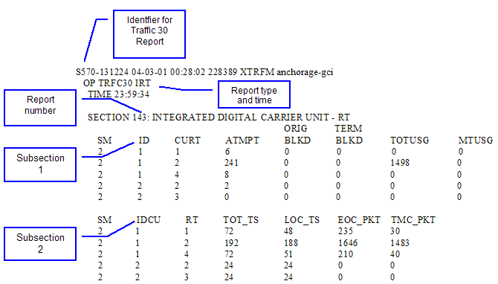

The Lucent 5ESS switches were originally designed to output data to a form feed printer, not an IP socket. The 5ESS outputs all special characters associated with printers, such as form feed and device control. These are unprintable characters, so the only way to see them was to view the data in a hex editor. Fortunately OSS’s editor of choice, “UltraEdit”, easily toggles between hex and standard views. I viewed the bulk Traffic 30 output in UltraEdit noting which special characters were present at the end of each line and in between reports. These characters would need to be deleted from the final output, but could be used as flags to indicate the end of a line of data.

4. Implementation

In early January, OSS split the data stream of the Traffic 30 port to feed both the production serial connection and a development IP router. I was given access to a port on this router and the OSS unix environment. This allowed me to develop and test my scripts without interfering with the production feeds.

The initial script I wrote used OSS’s code for capturing data from a socket connection as a starting point. I began by creating the logic to parse the header of each sub-report to find the identifiers for report type and report time. I then added a subroutine to write each sub-report into its own file.

Once I could successfully identify and output each sub-report, I began working on the logic to parse out the data that would eventually be written into the database. My first step was to create a method of testing that did not rely on the live data streams, as the data streams were only active for half an hour. As a solution I created a script that read from a file instead of the live data stream and used a file of the bulk data feed to test against. This allowed me to test with the same data as the live feed, without the inconvenience of waiting for the live feed every hour.

My initial data structure for parsing the reports was arrays. I created an array for each line in the section report, then pushed the arrays together into one long array at the end of each section report. Arrays worked well for the simple reports that did not have row fields spanning multiple lines of data. However, arrays proved to be cumbersome for the larger section reports. Using arrays was further complicated by section reports that did not consistently output the same number of lines.

I consulted with Doug, who suggested using a hash instead of an array for the more complicated section reports. This quickly proved to be an excellent suggestion. The number of lines per portion of section report would no longer be an issue, since the hash logic would be recognizing a unique key and would not need to keep track of the number of lines per section. Also, I could implement the hash with about one-third the amount of code the arrays required.

The hash worked so well I converted all the section reports to use hashes instead of arrays. I added a subroutine to dereference the hash and print out the hash’s contents to a file to verify I was correctly writing all the data into the hash. The end result was a script called “Traffic_30_Reports” which contained subroutines to evaluate the section report’s headers, subroutines to write each section report into a hash, and subroutines to write the hashes to a file for debugging.

By mid March the section reports were being parsed correctly and it was time to concentrate on the database. Doug created a test database identical to the one used for production. I reviewed a series of scripts from other programmers in OSS using Perl to connect to a database and run queries. Using those scripts as a model, I wrote my own script “Write2Database” which takes in the report type, report time, and a reference to the sub-report’s hash as parameters from “Traffic_30_Reports.” It then builds an SQL insert statement from those parameters and pushes each insert statement onto an array of insert statements. After “Traffic_30_Reports” finishes parsing the sub-reports into hashes and the SQL insert statements have been written, the subroutine “connect_To_Database” establishes a connection to the database and iterates through the array of insert statements, executing one insert statement at a time.

Figure 3: New Design

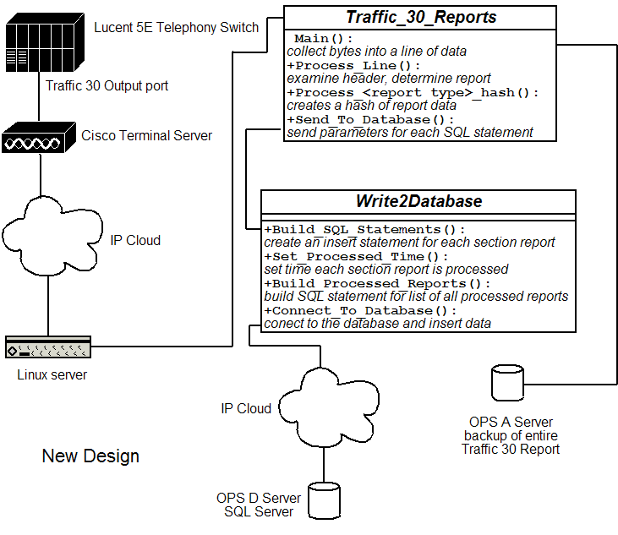

5. Testing

Once the “Traffic_30_Report” and “Write2Database” scripts had been written and tested with the file, it was time to start testing with the live data streams. I added the functionality for socket connections to “Traffic_30_Report” and began writing to the database from the live data stream.

Reading from a live data stream instead of a static file highlighted an issue I had yet to address. The Lucent 5ESS switches do not output an indication of when the data feed is complete. There is no end of file flag. I dealt with this in the version of “Traffic_30_Report” that read in a static file instead of listening to the socket connection by making the calls to build the SQL statements within the evaluation of the last report in the file. Clearly this would not be acceptable in the final product, as not every switch in the network outputs the same reports. Any switches that did not output the same last report as I was keying off of to make the call to the database would never get processed.

The simple fix was to add in a timer to detect when the script had not received data after one minute. Then I encapsulated the calls for building the SQL statements into a subroutine which would be called when the timer ran out. The script was modified to include an “infinite” while loop using the timer to detect the end of the data feed then build the SQL statements as described.

Once the script was capable of looping indefinitely I ran a series of tests to confirm data could be successfully written to the database over at least a twenty-four hour period.

6. Recommendations

There are a number of improvements that could still be made to the two scripts I wrote. Given more time I would have liked to explore the possibility of writing each section report to the database immediately after it has been processed into the hash. This would make the data accessible in virtually real time. Doug and I discussed this as a possibility early in the design process, but eventually discarded it due to concerns with buffer management. The section twelve report is the largest of all the section reports, it takes up eighty-five percent the space of the entire Traffic-30 output. Doug and I were concerned the time it would take to write the section twelve hash to the database would interfere with the data collection of the rest of the Traffic 30 report. We did not want to introduce the complexity of threads into this design and decided to explore the possibility of a virtually real time transfer at a later date.

I would also have liked to add functionality for notifying OSS when a new section report has been turned up. It is very common for the switch technicians to turn up new section reports without notifying OSS first. In my current design, such reports would get written to the archive file but OSS would not know there was a new file being output until a switch tech tells them. Perl has modules for sending emails and I believe the most effective design would identify when a new section was being output and send OSS an email notification

However in general I am satisfied with my results and Doug has accepted the code. OSS is responsible for a number of processes similar to the Traffic 30 reports and will likely revise them using this design as a template.

Information for the GCI Company Overview was extracted from http://www.gci.com/about/coover.htm.

