Mosaic Creator

Lance Finfrock
CS 470

April 20, 2004
Table of Contents

Abstract 1
1. Introduction 1
2. Project Overview 1
3. Project Requirements 2
3.1 Functional Specifications 2
3.2 System Specifications 2
4. System Design 3
4.1 Picture Files 3
4.2 Graphical User Interface 4
4.3 Interactive Viewer 5
4.4 Data Structures 6
4.5 System Architecture ………………………………………………………………..7
4.6 Algorithms …………………………………………………………………………8
5. Software Development Process 11
5.1 Incremental Prototyping 11
5.2 Testing and Debugging 11
5.3 Work Breakdown 12
6. Results 14
7. Summary and Conclusions 14

Mosaic Creator
Lance Finfrock
Abstract
A mosaic is an image that is comprised of hundreds or thousands of other images to create one total image. The three main objectives in this project were to provide an interface to the user, to create and display the mosaic, and for the mosaic to be able to be printed and saved. The program was created in java with an incremental prototyping methodology. The algorithm used to create the mosaic finds the difference between each image by their color values. The project produced an easy to use and enjoyable program. There are plans for beta testing.

1. Introduction
Take your everyday traditional pictures and turn them into a modern work of art. Mosaic Creator takes a fresh creative approach to the way pictures are composed. Using hundreds of your own personal pictures, Mosaic Creator will create for you a masterpiece, a single image comprised of hundreds of smaller images. Photographs, drawing, and paintings will never be the same again. Mosaic can take your favorite family vacation photo and allow you to relive the memories while exploring the many images from your trip that are now blended within. Hours of fun can be spent designing your own creations. Your imagination is the limit.
This project was developed for use by the general computer user. I am assuming that a general computer user has some knowledge about images in the computer, for example JPEG format, and a basic idea of how a computer’s directory system works. Since this project does not have a target user, the user interface is an extremely important portion of the project.

2. Project Overview
The goal of this project is to develop an easy-to-use program that creates a mosaic image. Mosaic images are used in advertising and for home personal use. This project will allow the average person who has images on their computer to create a mosaic and be able to print and/or save these images.
A mosaic image is an image comprised of hundreds or thousands of other images. An image that is part of a mosaic will be called a mosaic piece. A mosaic is created with a set number (specified by the user) of mosaic pieces wide and high with each piece being of the same size. Needing all of the images to be the same size creates a problem because not all images have the same proportions. When an image is created into a mosaic piece it is shrunk to the appropriate size for that section. Each of the mosaic pieces resembles a section of the overall mosaic image.

- Project Requirements
The requirements for this project have three main objectives: one is to provide an interface to the user, two is to create and display the mosaic, and three is for the mosaic to be able to be printed and saved. The other features in this project were not part of the project requirements.

3.1 Functional Specifications

1. Provide an interface to the user. This interface must be self explanatory and easy to use.

2. Create the Mosaic. The program must create a mosaic by the default option of allowing duplicate images in the mosaic.

3. Displaying the Mosaic. The program must display the mosaic image and allow the user to enlarge the mosaic pieces to a viewable level.

4. Saving and printing the Mosaic. The mosaic image must be able to be printed and saved to disk.

3.2 System Specifications
The program was created with Java Virtual Machine 1.4.1 on Windows XP. At a minimum, the system should have 128 MB of memory and run at speeds of 1.0 GHz. The program was created with a video adapter of resolution 1024 by 768, but the program will work with the minimum screen resolution of 800 by 600. The program is not known to work with video adapters of a different resolution.

4.0 System Design
Java was chosen as the programming language for this project in order to create an object-oriented design and to allow the program to work on UNIX and Mac operating systems. By choosing a window-based interface the design is event-based driven.

4.1 Picture Files
The images used for this program can only be in two formats: JPEG and GIF. Any other formats that are not comparable to these will not be used by the program. This program may not create an ideal match to the original image if there is not enough distribution in colors in the mosaic pieces provided.
Each image will be read into a data structure (see section 4.4) and analyzed as described in section 4.3. The end image will be stored in the JPEG format.
All the files used for the program will have to be designated by the user. The program will have a directory listing where a user can choose which files they might want in their mosaic.

4.2 Graphical User Interface
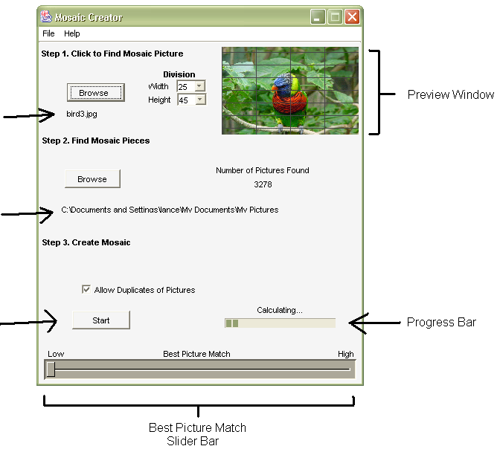
The graphical user interface was created with the idea that it is one of the most important parts to this project. In this project, the graphical user interface is one of the most important parts because this project is targeted for the general public, including users without a good grasp of computer architectures.
File Chosen to create the mosaic
Folder chosen where the mosaic pieces can be found
Figure 1.
Button used to start the creation of the mosaic
This window will be the home screen to the program, it will provide information needed for users to follow the steps, and create a mosaic.

Step 1
In step one the user can browse through their system to find the image that they want to use to create the mosaic. The “Browse” button will bring up another window like the ones used in Microsoft Windows programs. When the user has chosen the main image, it will be displayed to the right of the path name.

Step 2
In step two the user will provide the folder where the images for the mosaic pieces are located. The user can perform this task the same way as described above. Once a folder has been specified, the number of images found will be displayed under the label “number of pictures found”.

Step 3
In step three the user is ready to start to create the mosaic image. When the user clicks the button labeled “Start” the program will began to create the mosaic, and the bar to the right will increases as the program is closer to completion. When the program is finished creating the mosaic the main interface will display a “View” button that allows the user to view the mosaic in the Interactive viewer.

4.3 Interactive Viewer
The Interactive viewer is where the user gets a chance to view the final output of the program. When a user slides their mouse over an image in the mosaic, the image will be increased in size to allow the user to view one image in more detail (Figure 2). If the user clicks an image in the mosaic, a new window will appear displaying the full size image.
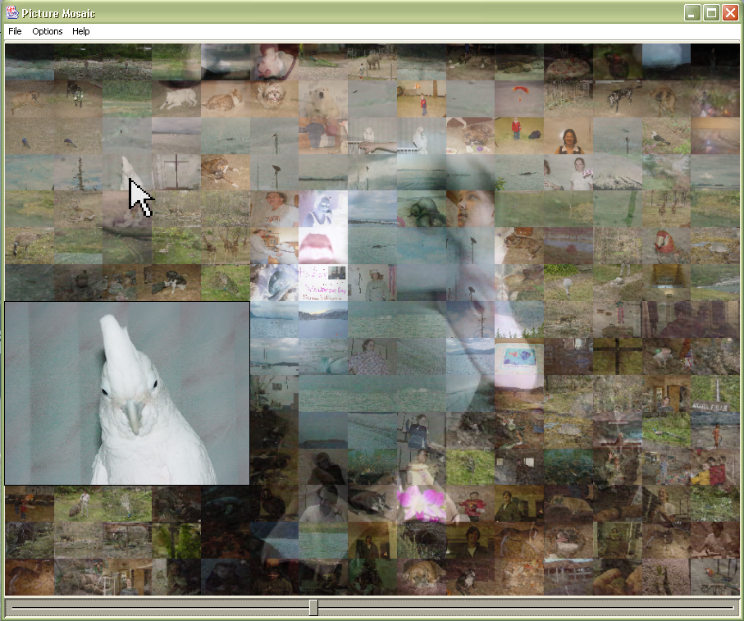
Figure 2.
4.4 Data Structures
Mosaic and PicPixels are the two data structures that where created for this project. The Mosaic data structure is the complete data needed to create a mosaic image. The Mosaic data structure is outlined below.
Class Mosaic {
divisionsHigh : int
divisionsWide : int
originalPicture : PicPixels
subPiecesPixels : PicPixels[]
}
These four attributes are what are needed to create a mosaic image. The “divisionsHigh” and “divisionsWide” attributes specifies how many mosaic pieces the mosaic is high and wide. The “originalPicture” attribute is a PicPixels object that contains information for the image that this mosaic was created to match. The “subPiecesPixels” attribute contains all the mosaic pieces’ information. The order that the pictures are in the array is the order they are in the mosaic image.
The PicPixels data structure is used to store all the information needed for an image. The main attributes for this data structure are show below.
class PicPixels{
filePath : String
height : int
width : int
pixels : int[]
getColor( int x, int y) : Color
}
Each image used by this program is stored in this format. The attribute “filePath” is the local directory path to the image. The attributes “height” and “width” are the dimensions of the image in pixels. The attribute “pixels” is an array of all the pixels in the image. The method “getColor” is the way to access the color values of each pixel.

4.5 System Architecture
The overall system was decomposed into the major modules shown in Figure 3. In the design, the main window display is the interface which starts all the other processes. This module contains the only copy of the mosaic created in order to decrease on memory use. From this window, the open mosaic, mosaic algorithm, and file finder modules can be started. Each of these modules is used in creating a mosaic. The Interactive viewer can not be started until a mosaic is created. From the Interactive viewer the print and save modules can be called. The print and save modules are the only method that allow the user to produce an output of their currently created mosaic. Once the Interactive viewer is closed, the control goes back to the main window display where another mosaic can be created.

Main Window
Display
Mosaic
Algorithm
Interactive
Viewer
Open
Mosaic
File Finder
Save
Print
Figure 3.

4.6 Algorithms
The mosaic creation and blending algorithms were the two main algorithms used in the Mosaic Creator to create a mosaic. Creating these algorithms to perform their tasks with speed and accuracy was how most of the development time was used.

- Mosaic Creation Algorithm
The mosaic creation algorithm is a straight forward way of creating a mosaic. This algorithm is called with: an image the mosaic is supposed to resemble (original image), a large collection of images (mosaic pieces), and two integers that tell how many images wide and high the mosaic is to be.
The first task the algorithm performs is to read in the original image and the mosaic pieces to memory. Each of these images read in are stored as a PicPixels object. The original image is then broken down into sections corresponding to the size of a mosaic piece (Figure 4). Then each section is compared to all of the mosaic pieces to find the piece with the least difference. The example below is showing one section of the original image compared to a collection of mosaic pieces.

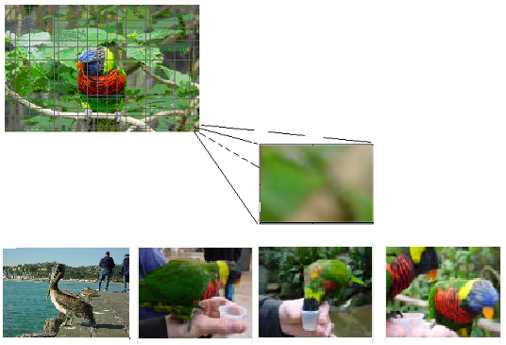
Original image
Mosaic pieces
Section of the original image
Figure 4.

Finding the difference between each section and a piece is a straight forward method of comparing each pixel color. Figure 5 shows a section of the original image and a mosaic piece being compared. For each pixel in the section and the corresponding pixel in the mosaic piece, the red, green, and blue color values are obtained. The difference is found between each red, green, and blue value separately, and is then added together. This value, belong with the values found from the other pixels, are added together to create the difference between the original section and the mosaic piece. A large portion of the run time is spent finding this difference.

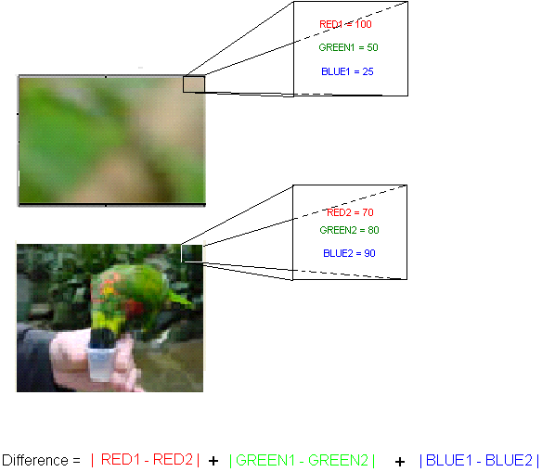
Mosaic piece
Original section
Color values
Figure 5.
Choosing the best mosaic piece for each section of the original image has two options. The first option is to allow an image to be used more than once. In this method when a mosaic piece is found to be the best match for that section it is selected, assigned to that section, and then placed back into the pile of mosaic pieces so that it can be chosen again. The other option is to not allow duplicate images in the mosaic. With this option, when a mosaic piece is selected it is not placed back into the pile, therefore it will not be selected again. This option is only possible if the user provides as many images as there are sections in the mosaic being created.
- Blending Algorithm
The blending algorithm is used to more closely match the mosaic to the original image. This algorithm is called from the Interactive viewer after the mosaic is created. From the Interactive viewer the user can see an immediate response from the blending algorithm by using the slider bar (Figure 6). Because of this immediate response, the algorithm had to be as quick as possible. The blending algorithm is called every time an image is displayed to the screen, saved, or printed.

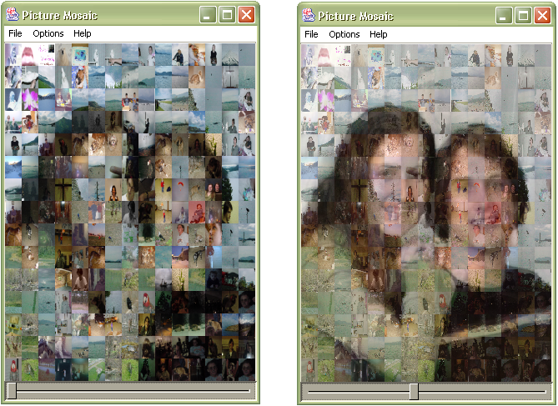
Slider bar
Figure 6.
The blending algorithm uses the technique of weighted averaging of the original image and the mosaic pieces. In Figure 6 the image on the left has no blending added to it whereas the image on the right has almost an equal average. The method used here is when the image is created each pixel color is found by finding the difference in each separate color (red, green and blue) and adding or subtracting a percentage of that difference from the color value of the mosaic piece. The percentage that is added or subtracted is specified by the user moving the slider bar at the bottom of the Interactive viewer to the left or right.

5.0 Software Development Process
The software development process used was incremental prototyping. At each stage in the incremental prototyping, testing and debugging was preformed.

5.1 Incremental Prototyping
The incremental prototyping methodology was used in the design of this project. The reasons why incremental prototyping was used are because the graphical users interface had a high priority of being user friendly, I did not know what features were possible to create, and I needed to test each step in the progress with the other operating system (UNIX, Macintosh).
The graphical user interface (GUI) is one of the most important parts of this project. Since this project has a target audience of the general computer user, I believe that if the GUI is not completely intuitive to the user, they will give up and not use the program. Most of the development time was spent creating a GUI that the user could understand and not be able to break.
Throughout the project each step was ended with a complete and running program. The project was designed in this block manner because I did not want the project to depend on the other features that might not be implemented. The main steps in the development were the Mosaic creation algorithm, the GUI, the Interactive viewer, the blending algorithm, printing, and saving.
At each step along the process I tested the program with Red Hat 9.2 operating system. The main problem that I had found with running the program with Red Hat was the GUI did not look the same as Microsoft Windows. When running the GUI, labels and buttons would disappear and get cut off. I did find that all of the algorithms worked with no problems in the UNIX environment. I planned on testing the program in a Macintosh environment, but I was unable to install the required Java Virtual Machine on my test computer.

5.2 Testing and Debugging
Major testing and debugging was done at each step in the incremental prototyping process. Most of the debugging was done trying to show increasing progress bars, catching JPEG images errors, and trying to only have one copy of a mosaic in memory at a time. The tests that I ran at every stage in the development were:
- Create a mosaic with only 10 different images with the dimensions of 15 by 15
- Create a mosaic with 3,500 different images with the dimensions of 60 by 60
- Create a mosaic where the proportions of the mosaic piece would be incorrect
- Every time in the Interactive viewer move the slider bar two the far right and left and in the middle
- Try to chooses files that were not JPEG or GIF
- Choose a folder that did not have any images in them
- Save a mosaic as a .mosaic and then move the images around in the computer file directory and reopen the mosaic
- Stop the process of creating the mosaic at every point possible
- Try to open and create a mosaic at the same time
- Try to open as many Interactive viewer as possible
- Try to print a mosaic without a printer
- Try to resize all of the windows in the program
- Try to save and print at the same time

5.3 Work Breakdown
Below is a breakdown of the work schedule.
Task Start Date Duration in days
Initial Planning 1/12/2004 2
Initial Requirements 1/14/2004 3
Initial Design 1/19/2004 2
Write Proposal 1/20/2004 1
Research Displaying Images 1/21/2004 2
Research Images in Java 1/23/2004 3
Research Windows in Java 1/26/2004 5
Create Prototype 2/1/2004 10
Test Mosaic Algorithms 2/11/2004 18
Create Directory Browser 2/29/2004 3
Research Blending Algorithm 3/3/2004 5
Research Mouse Over View 3/8/2004 5
Research Printing in Java 3/13/2004 5
Research Saving JPEGs in Java 3/18/2004 5
Create Final Program 3/23/2004 10
Test Program 4/2/2004 5
Final Presentation 4/7/2004 9
Final Write Up 4/16/2004 9
Code Review 4/25/2004 1
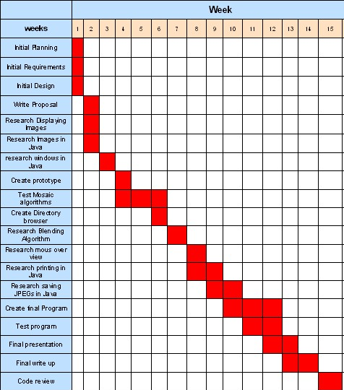
6 Results
The Mosaic Creator application was completed on time for the demo day on April 26. All of the users that have tested this program have found it easy to use and enjoyed creating mosaics. I plan to release this project to a small group of users for beta testing. After the beta testing I plan to release the project for free to use.

7 Summary and Conclusions
This project was developed in Java with the goal of creating a program that takes in an image and a folder of images and creates a mosaic. Because the user interface had to be user friendly, I chose to use the incremental prototyping development methodology.
This project has expanded my knowledge in manipulation of images, working with printers, programming threads, and creating graphical user interfaces.
Overall I found this project to be challenging, although enjoyable to work on and test. Prior to beginning this project, I had minimal experience working with images in Java and other languages. I have gained a large amount of experience in the process. The mouse over programming, which I have never used, was a great tool to learn and will be use for future projects. The most important thing that I have gained from this project is the skill of developing a project from the ground up, and the skill of developing a project which I hope to use in the work force in the future.

