A Space Game

CS470
Applied Software Development
Design Documentation

William Sistar
February 4, 2004
Abstract
A Space Game is a team based multi-player game that will be played across a network. The game is designed to be played with at least four players. Players would be in teams of at least two, where one of the players is a pilot and the other player would be a gunner. The game will be played in an arena which will provide a physical bound to the playing field. The pilot will be responsible for flying and maneuvering the ship, while the gunner will be responsible for firing and managing all weapon systems. The winner is the last ship alive. The game is designed to be a proof of concept and as such will only meet the minimum requirements.
Table of Contents
1.0 Introduction 1
2.0 Planning Process and Overall Game Design 1
2.1 Initial Process 1
2.2 Server design 2
2.3 Client design 5
2.4 Game design 5
3.0 Algorithms 6
3.1 Collision Detection 6
3.2 Realistic Zero-g Motion 6
3.3 Communication Protocol 6
4.0 Analysis and Discussion 7
5.0 Conclusions 7
6.0 Lessons Learned 7
7.0 Requirements 7
Appendix A: User Manual i
Installation i
SERVER i
CLIENT/GAME i
Starting server i
Starting the client i
Game Commands iii
Arrow keys iii
Keyboard iii
Function keys iv
Joystick(3-axis) iv

1.0 Introduction
A Space Game (ASG) is a team based multi-player game that will be played across a network. The game is designed to be played with at least four players. Players would be in teams of at least two, where one of the players is a pilot and the other player would be a gunner. The game will be played in an arena which will provide a physical bound to the playing field. The pilot will be responsible for flying and maneuvering the ship, while the gunner will be responsible for firing and managing all weapon systems. The winner is the last ship alive.
Designing and writing A Space Game (ASG) will tackle many problems. Each problem on its own is not too difficult, but when combined create a complex problem with many possible solutions, where each solution has its benefits and drawbacks. The following is a list of the problems ASG will attempt to address and overcome:
- Networking
- Threading
- Scalability
- Collision detection
- Cross-platform compatibility
- Security
- Client synchronization
- Realistic zero-g motion
- Messaging
- Multiple applications
- Production

2.0 Planning Process and Overall Game Design

2.1 Initial Process
When I started this project I only had a vague idea of how it should be designed and what should be required. Since I did not have a real client, other than myself, I started prototyping the ideas I had for the game. As I started prototyping, many of the requirements became obvious. As I ran into problems through prototyping I started developing a better design. I decided to break up the requirements into three categories: Absolutely must be met, highly desirable but are not necessary, possible but could be eliminated.
Absolute
- Will communicate with a dedicated network server
- Game server will receive messages from players, interpret them, and handle them appropriately
- Players’ computers will receive messages from the server, interpret them, and handle them appropriately
- A communication protocol for passing various types of information
- A basic arena
- A basic ship
- A basic weapon
- Collision detection for the ship in the arena and with other ships
- Data structure to store players/users on the server
- Data structure to store players in a game
- Use of a graphics API for displaying the game
- Game must update each player’s display so that the pilot and gunners on the same team are in the same position and the gunners maintain the same relative view
- Allow for player selection of player position (pilot, gunner1, gunner2)
- Smooth display of enemy ships when in view
- Server will allow players to login
- Client will remain logged in until the client chooses to exit
- Server will allow the creation of games from authorized clients
- Game will be capable of handling 2 ships/teams
- Teams will consist of minimum 2 players (pilot and gunner)

Highly desirable
- Server will provide security (i.e. user name and password)
- Server capable of handling multiple games (25 or more) with no apparent degradation to any of the games.
- Fluid/smooth and accurate display of opponents ships
- Each game capable of 4 ships
- Each ship capable of up to 3 players (pilot and up to two gunners)
- Multiple types of weapon ( machine gun, laser, pulse weapon, torpedo/missile)
- Multiple types of ships with different control characteristics
- Multiple types of arenas with different obstacles
- Ability for a user to create an arena, ship, or weapon for the game
- Arena provide power/health boost in random locations

Possible
- AI module that would allow a player to be replaced by the AI
- AI module that would allow a team to be replaced by the AI
- Multiple platform compatibility
- Joystick setup tool, allowing for user defined mapping
- Keyboard setup tool, allowing for user defined mapping

2.2 Server design
I had to make a decision early on about how the clients would communicate and whether or not I needed a server. Because I wanted the game to be scalable, I chose a client-server model. This model will take the burden off of each of the clients as to who to send the messages to and will allow the clients to spend more compute cycles on graphics. The server on the other hand can focus on passing messages to the appropriate clients to keep them synchronized. Since the server’s only function is to handles messages from clients, it will be able to do its job more efficiently. Figure 1 depicts the client-server model with the communication paths shown between a game and its clients.
Once I had decided on a client-server model, I needed to determine the process that a client would go through to logon to the server and then join or create a game. I decided at this point to create a login thread and administrative thread for managing these functions separately. Separating the login and the administrative threads provide two desirable features. First, a client would only have to know the login thread’s ip address and port number. Theoretically, the administrative thread and each of the game threads could be run on different machines. Once a client logged in successfully the login server would simply direct the client to the new ip address and port number. This could be setup to be completely dynamic for load balancing purposes, maintenance of a server, or upgrading with no downtime seen by the client. Secondly, since a client would not know the ip address and port number of the other services until he was authorized, denial of service attacks and general mischievousness could be thwarted at the login thread without adversely affecting games in progress. These of course are design issues that have been taken into consideration but will not be implemented, simply designed for. Figure 2 shows the final design choice for the necessary processes and threads. It also shows interprocess and network communication.

Game
Thread 1
Admin
Thread
Login
Thread
Comm
Receive
Thread
Game
Thread 2
Comm
Transmit
Thread
Client 1
Client 2
Comm
Receive
Thread
Comm
Transmit
Thread
Comm
Transmit
Thread
Comm
Receive
Thread
Comm
Transmit
Thread
Game
Thread n
Comm
Receive
Thread
Client 1
Client 2
Server
Figure 1. Client-server communication model

Login
Server Process
Thread
Admin
(3)
Thread
Threads
(2)
Game (1)
Client Process
Game Process
ASG Server
ASG Client / Game
Login
Create
Join
Game Play
Server communication
Figure 2. Process, thread, communication detail

As depicted in figure 2, the game will be separated into three main processes; the server, the client, and the game. I now had three processes that needed further design so a class abstraction was done for each process. The idea was to break out as many obvious objects as possible and then see how they needed to communicate. Figure 3 is the class abstraction for the server.

Server Main
Message Handler
Message
_games
_teams
_positions
Figure 3. Server class abstraction

Messaging was a critical requirement for the success of this project, so I abstracted out a message class and a messagehandler class. These two classes carried over to the client process and the game process as seen in figures 4 and 5. Since the server was not handling any graphics I simply made structures to handle the data for games, teams, and positions.

2.3 Client design
The client and game processes will run on the user’s machine. The client process will be responsible for communicating with the server for logging in, creating a game, deleting a game, and joining a game. The client process will then pass the address data of the joined game to the game process and stay resident so that when the game play is done the user can continue with other administrative actions. See figure 4.
Client Main
Message Handler
Message
UDP Client

Figure 4. Client class abstraction

2.4 Game design
The game process will only communicate with the associated game server thread. The ip address and port number of that thread will be passed in from the client. The process will be responsible for game setup and game play. The game will communicate to the server the necessary data to provide all players in the game appropriate information. Once game play has ended the process will be destroyed and you will return to the client process. See figure 5.
Main

Game

Arena

Pilot Display

Player

Spacecraft

Gunner Display

Team

Weapon

Texture Loader

Message Handler
Message
UDP Client

Figure 5. Game class abstraction and layout

3.0 Algorithms

3.1 Collision Detection
I needed a way to check to see if a laser fired from ship A hit ship B. Instead of using some more elaborate algorithms, I chose to use an algorithm that found the shortest distance between a point and a line. The idea was that with a laser I knew its starting point and ending point, and the game knew the location of the opponent. With that information, using a formula learned in Calculus III, I simply found the distance between the ship and the laser. If the distance was within a predetermined range it registered as a strike and returned true, otherwise it returned false.

3.2 Realistic Zero-g Motion
In space, once an object is set in motion there is so little atmospheric resistance that the object continues in that direction until some force is applied to change it. With that in mind, I used OpenGL’s built in matrix rotations to speed up the computation of all orientation based rotations. Roll, pitch, and yaw velocities were stored so that continuous motion would result as orientation type thrusters were applied.
Since the ship I am using only has one engine (at the rear) all acceleration is forward when a thruster is applied. I used the ship’s orientation vector for the direction and simply added to the current velocity vector each time a thruster was applied.

3.3 Communication Protocol
The following is the design for the messages that would be passed between the server and the client:
Format: int / int / int / data

The header ( int / int / int ) will include client id, message type, packet id and be parsed on “/”. The rest of the message (data) will vary in length and be parsed on spaces based on message type in the header.

4.0 Analysis and Discussion
There are several areas that need work with regards to the requirements. One is server authentication. Although a user is requested to enter a username and password, there is no actual verification. Stubs are in place to provide this service but the problem is I would also need a way of administratively adding new players. Another area that needs work is in the external display of the gunner of a ship. As the pilot increases the velocity of the ship, the gunner’s external view shows the ship being drawn twice, once in the center of the screen where it should be and one in the direction of the velocity vector with a distance directly related to the magnitude of the velocity.
Since this project was so pared down many of the features that would make a great game have been left out. These include features presented in the highly desirable and possible requirements listed earlier in this document.

5.0 Conclusions
This game includes many of the areas covered throughout my computer science education. They include networking, graphics, multi-threaded applications, object-oriented design, and C++. This has been a challenging and enjoyable project that shows my capabilities as a programmer.

6.0 Lessons Learned
This project was easily much larger than one person could handle in a semester, without some control on the requirements. Unfortunately the requirements had to be pared down to the point of a game that is just barely playable. One of the key lessons learned is that the code was relatively easy to write (with few exceptions). On the other hand, I went through at least three different designs and am still think it could be better.
If I were to work on a project like this again I would try to get in a group of two or three for two reasons. First, it would be easier to stay motivated working in a group of individuals who all have the same goal. And secondly, there would be more ideas on how to approach the problem with the idea that others in the group could help see problems that I may not on my own as ideas are presented.

7.0 Requirements
- Minimum of three computers: Server, client 1, client 2
- Client machines must support OpenGL
- Client machines need at least 128MB of RAM
- Although intended to be cross compatible, Windows networking restricts this to work only on Windows machines. (98, NT, 2000, XP)
- This should only be run on a LAN with a speed of 10Mbps or greater

Appendix A: User Manual

Installation

SERVER
- Move server files to server

CLIENT/GAME
- Install glut
- Install OpenAL
- Move client and game executables

Starting server
- Locate the asgs.exe on the server.
- Run asgs.exe.
- The server is now running.
  - Login thread is running on port 10000
  - Administration is running on port 10001
  - Default game thread is running on port 12000
  - New games will be created on ports starting at 12001
- The command window should look like this: 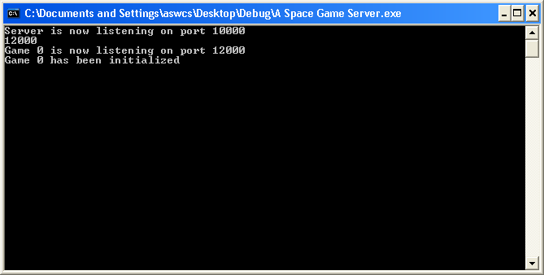

Starting the client
- Locate the asgclient.exe on the client machine.
- Run asgclient.exe.
- You will be asked for the IP Address of the server. Enter that now.
- You will then be asked for a username and password. Enter that now. (password is not actually verified). Once you have done this, you should see a screen like this: 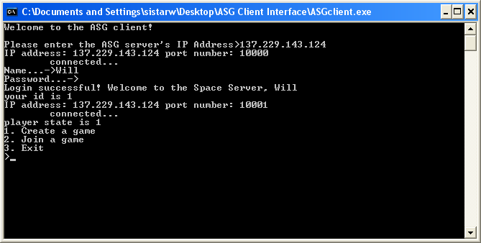
- Create game is currently not working. So you can either quit by selecting 3, or join the default game by selecting 2.
- After selecting 2, you will be asked to choose a team and then to choose a position. Your screen should now look like this: 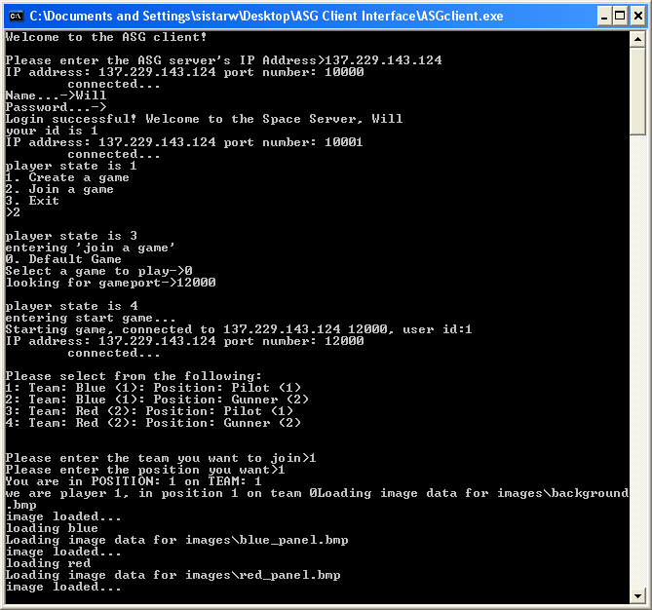
- Once the images and audio files have loaded the game will start. I have not been able to figure out how to shift the focus to the game window so you will have to select it with the mouse or by using ALT+TAB to cycle to it. Your view should now look something like this: 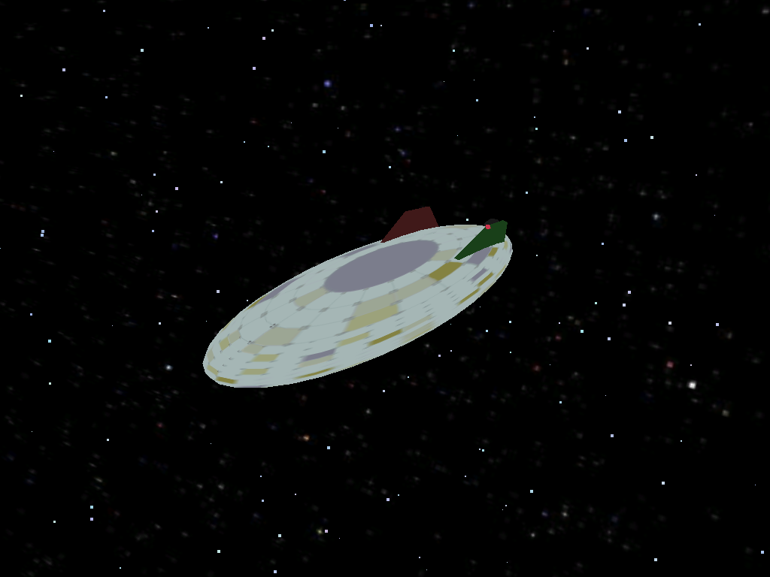
- You are now in the game and may commence destruction of your opponent.
- When one or the other team members wins, players will be notified appropriately.
- Press ESC to return to the client window.

Game Commands

Arrow keys
up – moves the nose of the ship down
down – moves the nose of the ship up
left – rolls the ship left
right – rolls the ship right

Keyboard
< – yaw control, rotates ship left
> – yaw control, rotates ship right
A – all stop, stops all rotation and change in position
B – increases the brightness of the HUD( heads up display )
b – decreases the brightness of the HUD( heads up display )
+ (plus key) – increase velocity
- (minus key) – decrease velocity
SPACE – fire weapon (laser)
ESC – Exit the game

Function keys
F1 – not used
F2 – toggle between external view and internal view
F3 – turn stars on and off
F4-F8 – not used
F9 – toggle music on and off
F10-F12 – not used

Joystick(3-axis)
Stick forward – pitch down
Stick back – pitch up
Stick left – roll left
Stick right – roll right
Twist left – yaw left
Twist right – yaw right
Button 1 – fire laser

